Car Type Classification

This project handles the classification of car models using four architectures:

* ResNet-50
* VGG-19
* Inception V1
* MobileNet V2

the training and preprocessing was done on the Stanford cars dataset:

([**https://huggingface.co/datasets/tanganke/stanford_cars**](https://huggingface.co/datasets/tanganke/stanford_cars))

Architectures

ResNet-50  
  
the primary mechanism for the ResNet architecture is the residual learning block where instead of mapping the input x to output H(x), the residual blocks approximates a residual function H(x) – x, denoted by F(x) and thus H(x) = F(x) + x.

This reformulation saves on the usage of multiple deep layers where instead of having to find the identical identity mapping of H(x) = x from a random initialization, it is efficient to say F(x) = 0.  
  
Resnet uses a multiple stage process of downsampling (step size = 2) the image through:  
- initial phase using a 7x7 convolution layer cutting dimensions in half and a 3*3 max pooling which halves it again  
- at the start of each stage (except the first stage) the image gets downsampled by half using a 3x3 convolution layer  
  
the bottleneck design which is for deeper residual networks (starting from resnet-50) uses:  
- 2 1x1 conv. layers that decrease and restore image channels  
- 1 3x3 conv. layer that learns the spatial patterns and downsamples the image   
  
by the end of the last stage the image goes through a global average pooling layer that collapses spatial image dimensions and finally It passes through a fully connected layer followed by a softmax layer  
  
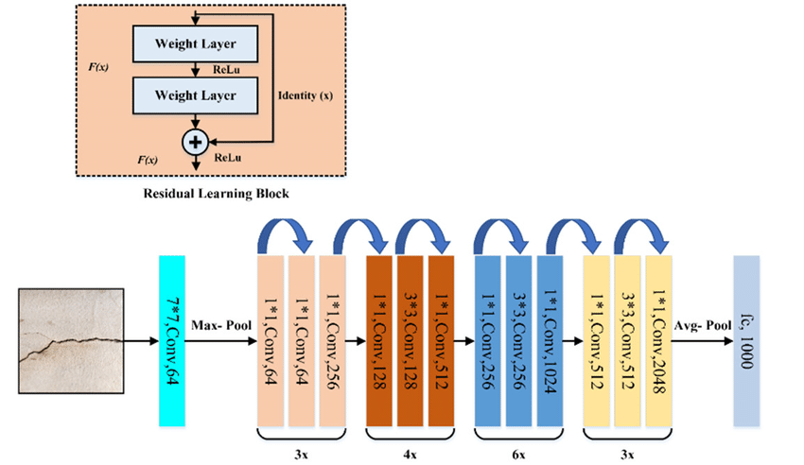  
  
  
  
  
reference: ***He, K., Zhang, X., Ren, S., & Sun, J.*** ***(2015).*** Deep Residual Learning for Image Recognition. *2016 IEEE Conference on Computer Vision and Pattern Recognition (CVPR)*, 770-778. <https://doi.org/10.48550/arXiv.1512.03385>

VGG-19  
  
VGG-19 follows a more straightforward structure by using five blocks consisting of convoluted layers followed by a max pooling layer, ending in 2 fully connected layers and a softmax.  
  
max pooling ensures that less intensive calculation and strong features being present in the image through it’s dimensionality reduction and, the convolution layers continue on capturing image information across multiple dimensions  
  
the convolution strategy uses 3*3 conv layers in all the 5 blocks spread out in:  
  
- Block 1-2 which use 2 convolution layers owing to the image’s large dimensions and the fact that large spatial information don’t need as much layers  
  
- Block 3-5 with 4 convolution layers as to increase the channels to capture finer details and representations with the benefit of lower computational costs due to reduced spatial size (from prior maxpooling layers)  
  
  
reference: ***Sudha, V. & Ganeshbabu, Dr. (2020).*** A Convolutional Neural Network Classifier VGG-19 Architecture for Lesion Detection and Grading in Diabetic Retinopathy Based on Deep Learning. Computers, Materials & Continua. 66. 827-842. [10.32604/cmc.2020.012008](https://doi.org/10.32604/cmc.2020.012008)

Inception V1  
  
The inception model uses a multi-scale approach that applies multiple convolution layers in parallel consisting of 4 branches:  
- 1x1 conv. layer  
- 1x1 followed by a 3x3 (the preceeding 1x1 reduce image dimension as to simplify following convolutions)  
- 1x1 followed by a 5x5  
- 3x3 maxpool followed by a 1x1 convolution layer  
The branches get concatenated by the end adding their channels together increasing feature depth by every inception module with each of them spread in 3 stages:  
- stage 1 with 2 modules, few modules due expensive cost on large image size, captures global features  
- stage 2 with 5 modules, smaller size so it captures mid-level features with increased modules  
- stage 3 with 2 modules, fewer modules as the model has progressed at a very deep level  
For a total of 9 inception modules.  
  
The architecture starts with 2 initial regular convolution layers to decrease dimensionality and retain strong features through max pooling at the end of each one of them and ends with a global average pooling layer which drops out 40% to prevent overfitting , a fully connected layer then finally a softmax.  
  
The model also features auxiliary classifiers after 2 modules of stage 2  
that passes the input though an average pool, a 1x1 convolution layer and 2 fully connected layers to finally softmax them, their purpose is during training to introduce some loss to be added to the main loss multiplied by a factor avoid the vanishing gradient problem  
  
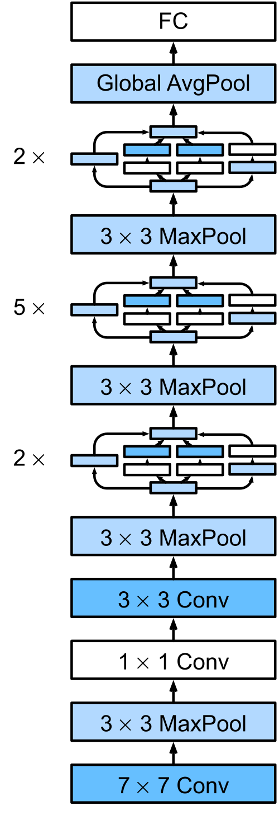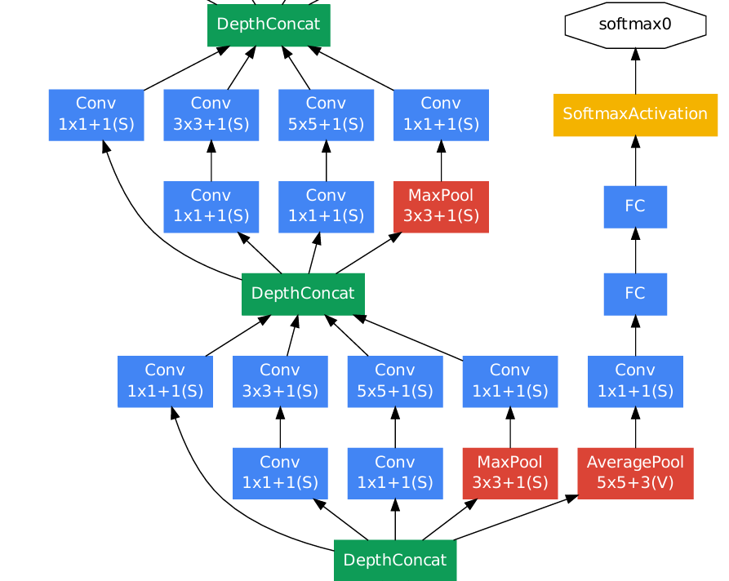  
  
reference: ***Szegedy, C., Liu, W., Jia, Y., Sermanet, P., Reed, S.E., Anguelov, D., Erhan, D., Vanhoucke, V., & Rabinovich, A. (2014).*** Going deeper with convolutions. *2015 IEEE Conference on Computer Vision and Pattern Recognition (CVPR)*, 1-9.  [https://doi.org/10.48550/arXiv.1409.4842](%20https://doi.org/10.48550/arXiv.1409.4842)

MobileNet V2

MobileNet’s architecture is based on the inverted residual block that reverses the traditional residual block where instead of reducing dimensions, convolving, then restoring it’s original size, it does the opposite, minimizing computational costs and maintain representational efficiency using the following structure:  
- 1x1 convolution layer that expands the image point-wise with ReLU6 activation  
- 3x3 depthwise convolution extracting features by applying separate filters per channel (uses same activation ReLU6)  
- 1x1 linear bottleneck which projects the image back into it’s original size with no activation function as ReLU cannot preserve information in low dimensions  
- Residual connection added to preserve information (ONLY when image dimensions match)  
  
Relu6 (output = min(max(0, x), 6)) is a new activation function included in first two layers of each inverted residual block. It’s purpose is preventing numerical instability in low precision computations as it was designed for mobile and embedded devices that has limited computational resources  
  
The architecture starts with an initial 3x3 convolution layer with stride size of 2 to reduce dimensionality, 19 blocks of inverted residual blocks then a global average pooling layer.  
  
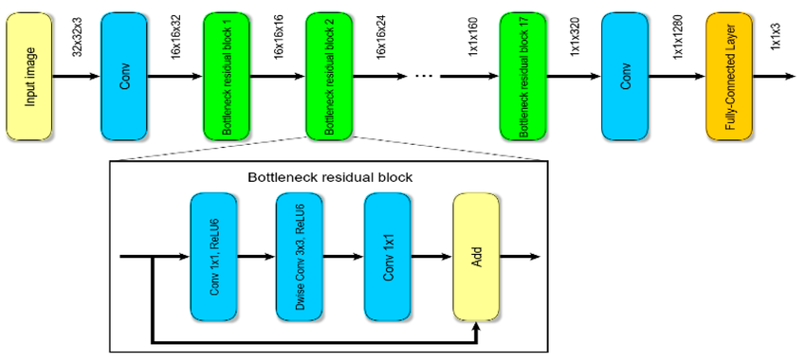  
  
  
reference: ***Sandler, M., Howard, A.G., Zhu, M., Zhmoginov, A., & Chen, L. (2018).*** MobileNetV2: Inverted Residuals and Linear Bottlenecks. *2018 IEEE/CVF Conference on Computer Vision and Pattern Recognition*, 4510-4520. <https://doi.org/10.48550/arXiv.1801.04381>

Comparative Analysis of Models

PERFORMANCE METRICS:

|  |  |  |  |  |  |  |
| --- | --- | --- | --- | --- | --- | --- |
|  | Accuracy | Precision | Recall | F-score | AUC Micro | AUC Macro |
| ResNet-50 | 0.840567 | 0.847793 | 0.839872 | 0.839799 | 0.998412 | 0.998415 |
| VGG-19 | 0.468101 | 0.499120 | 0.467837 | 0.466845 | 0.981045 | 0.980346 |
| Inception V1 | 0.384902 | 0.482860 | 0.382930 | 0.386226 | 0.961283 | 0.964898 |
| MobileNet V2 | 0.638229 | 0.668521 | 0.638801 | 0.638210 | 0.992139 | 0.992204 |

1. **ResNet50:**

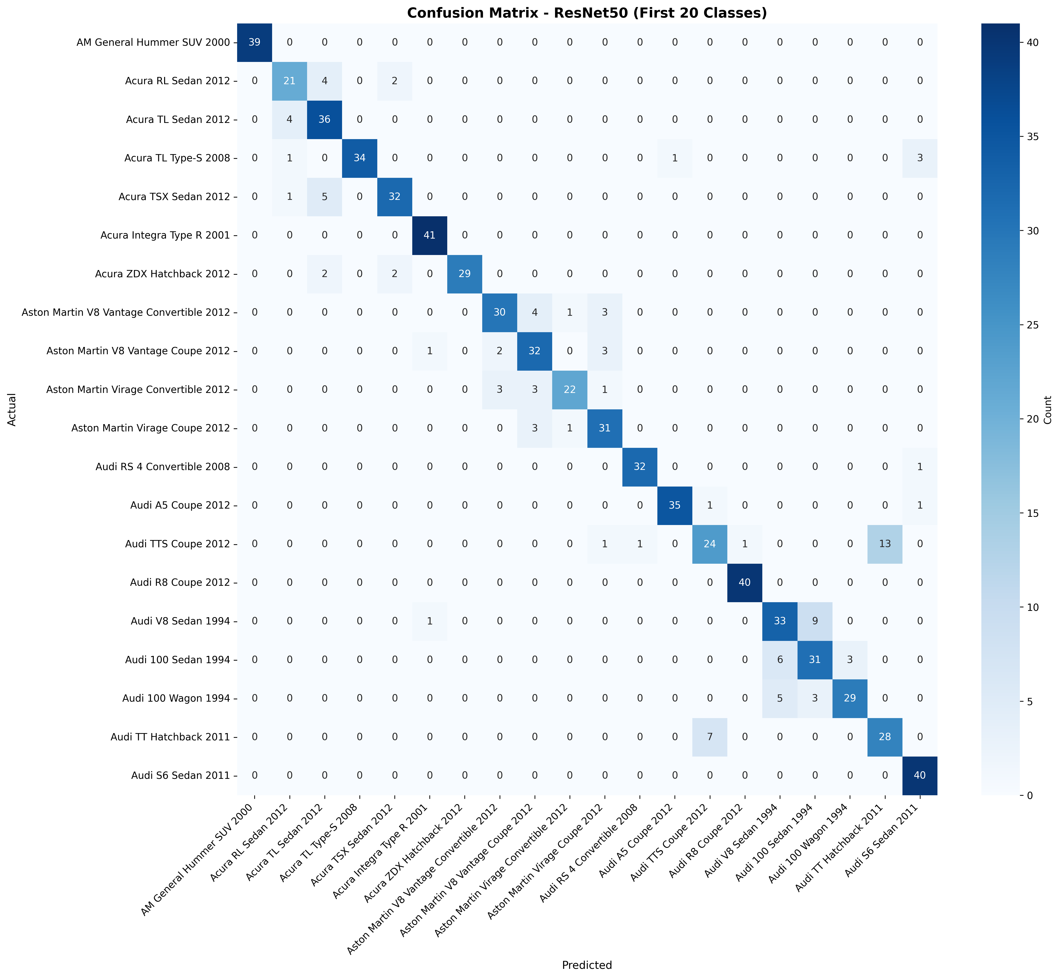

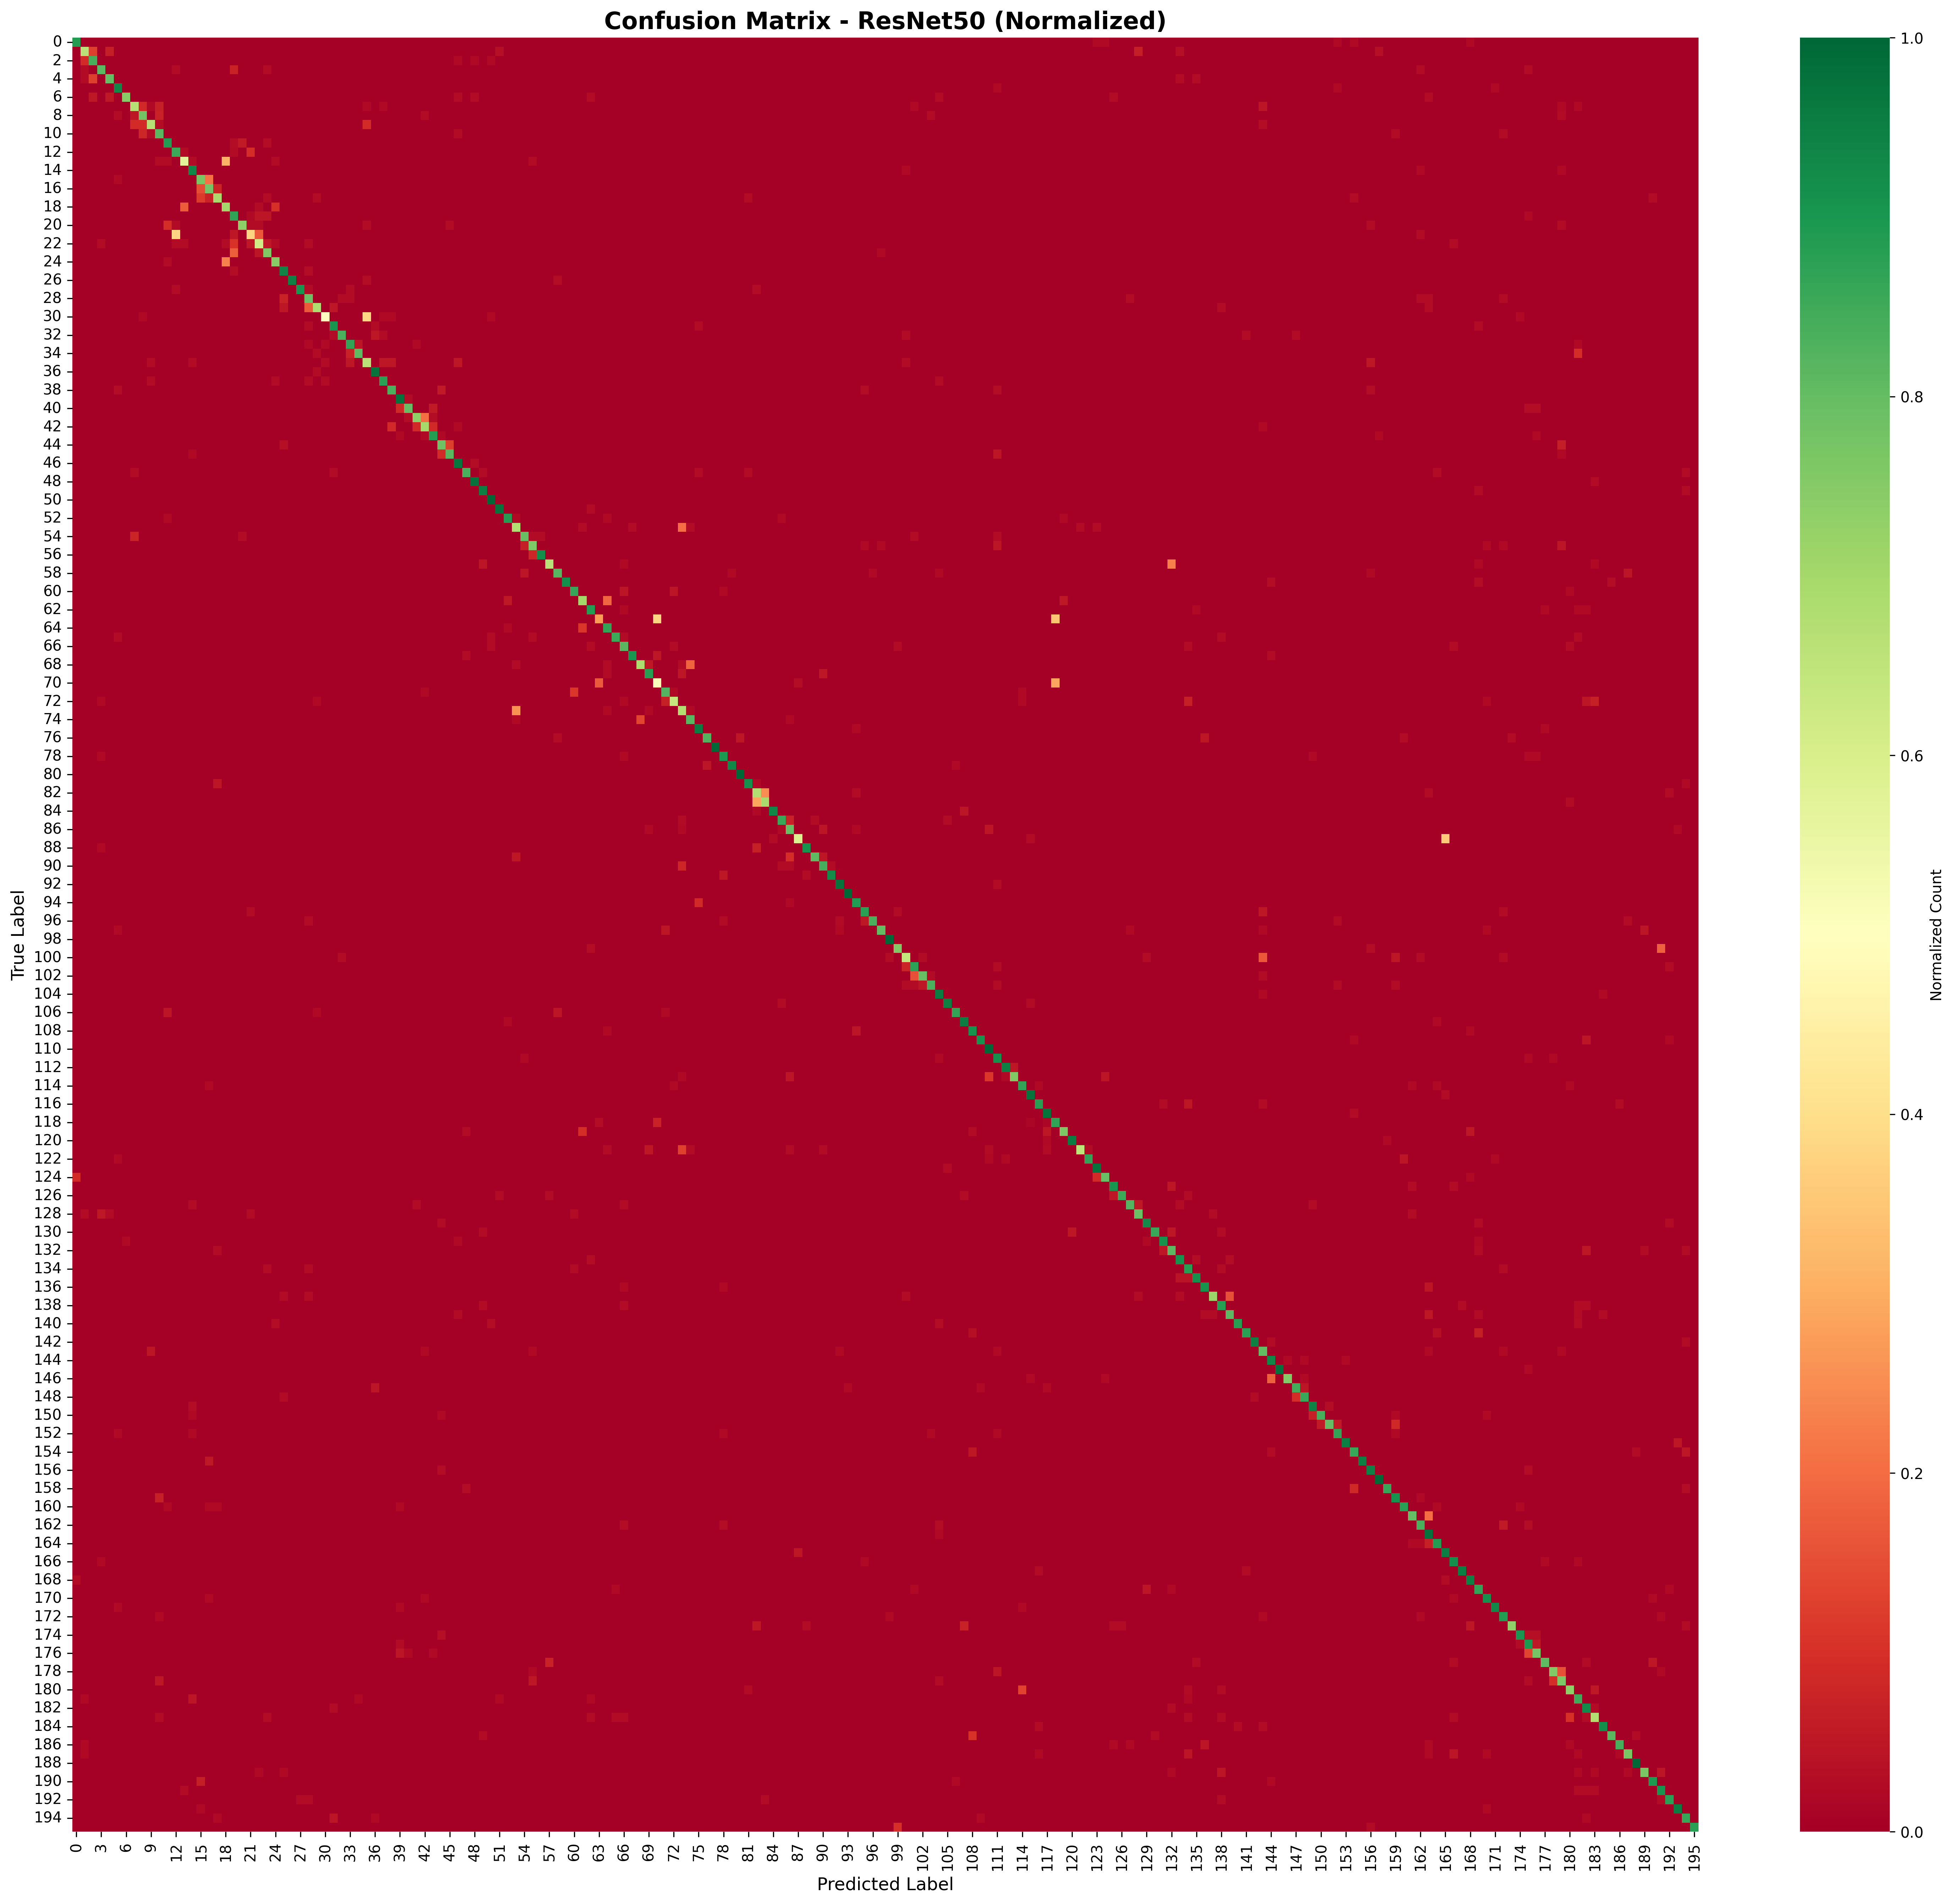  
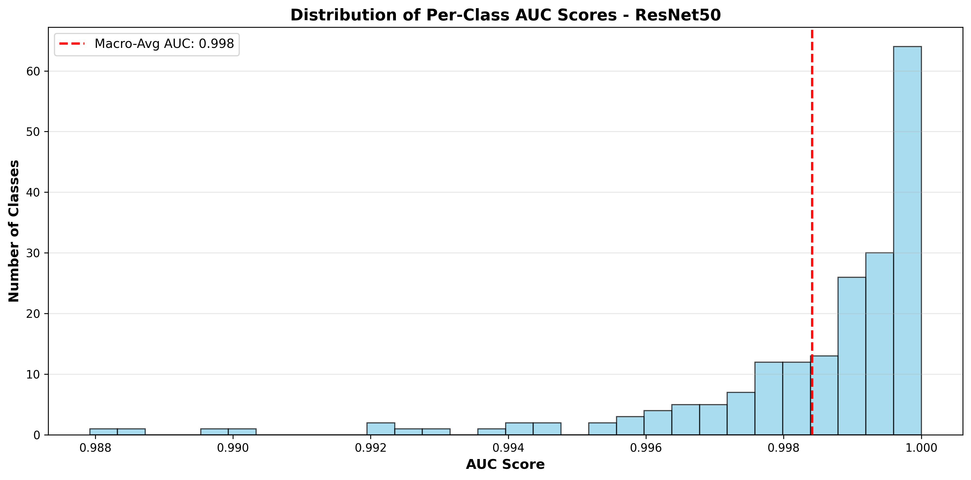

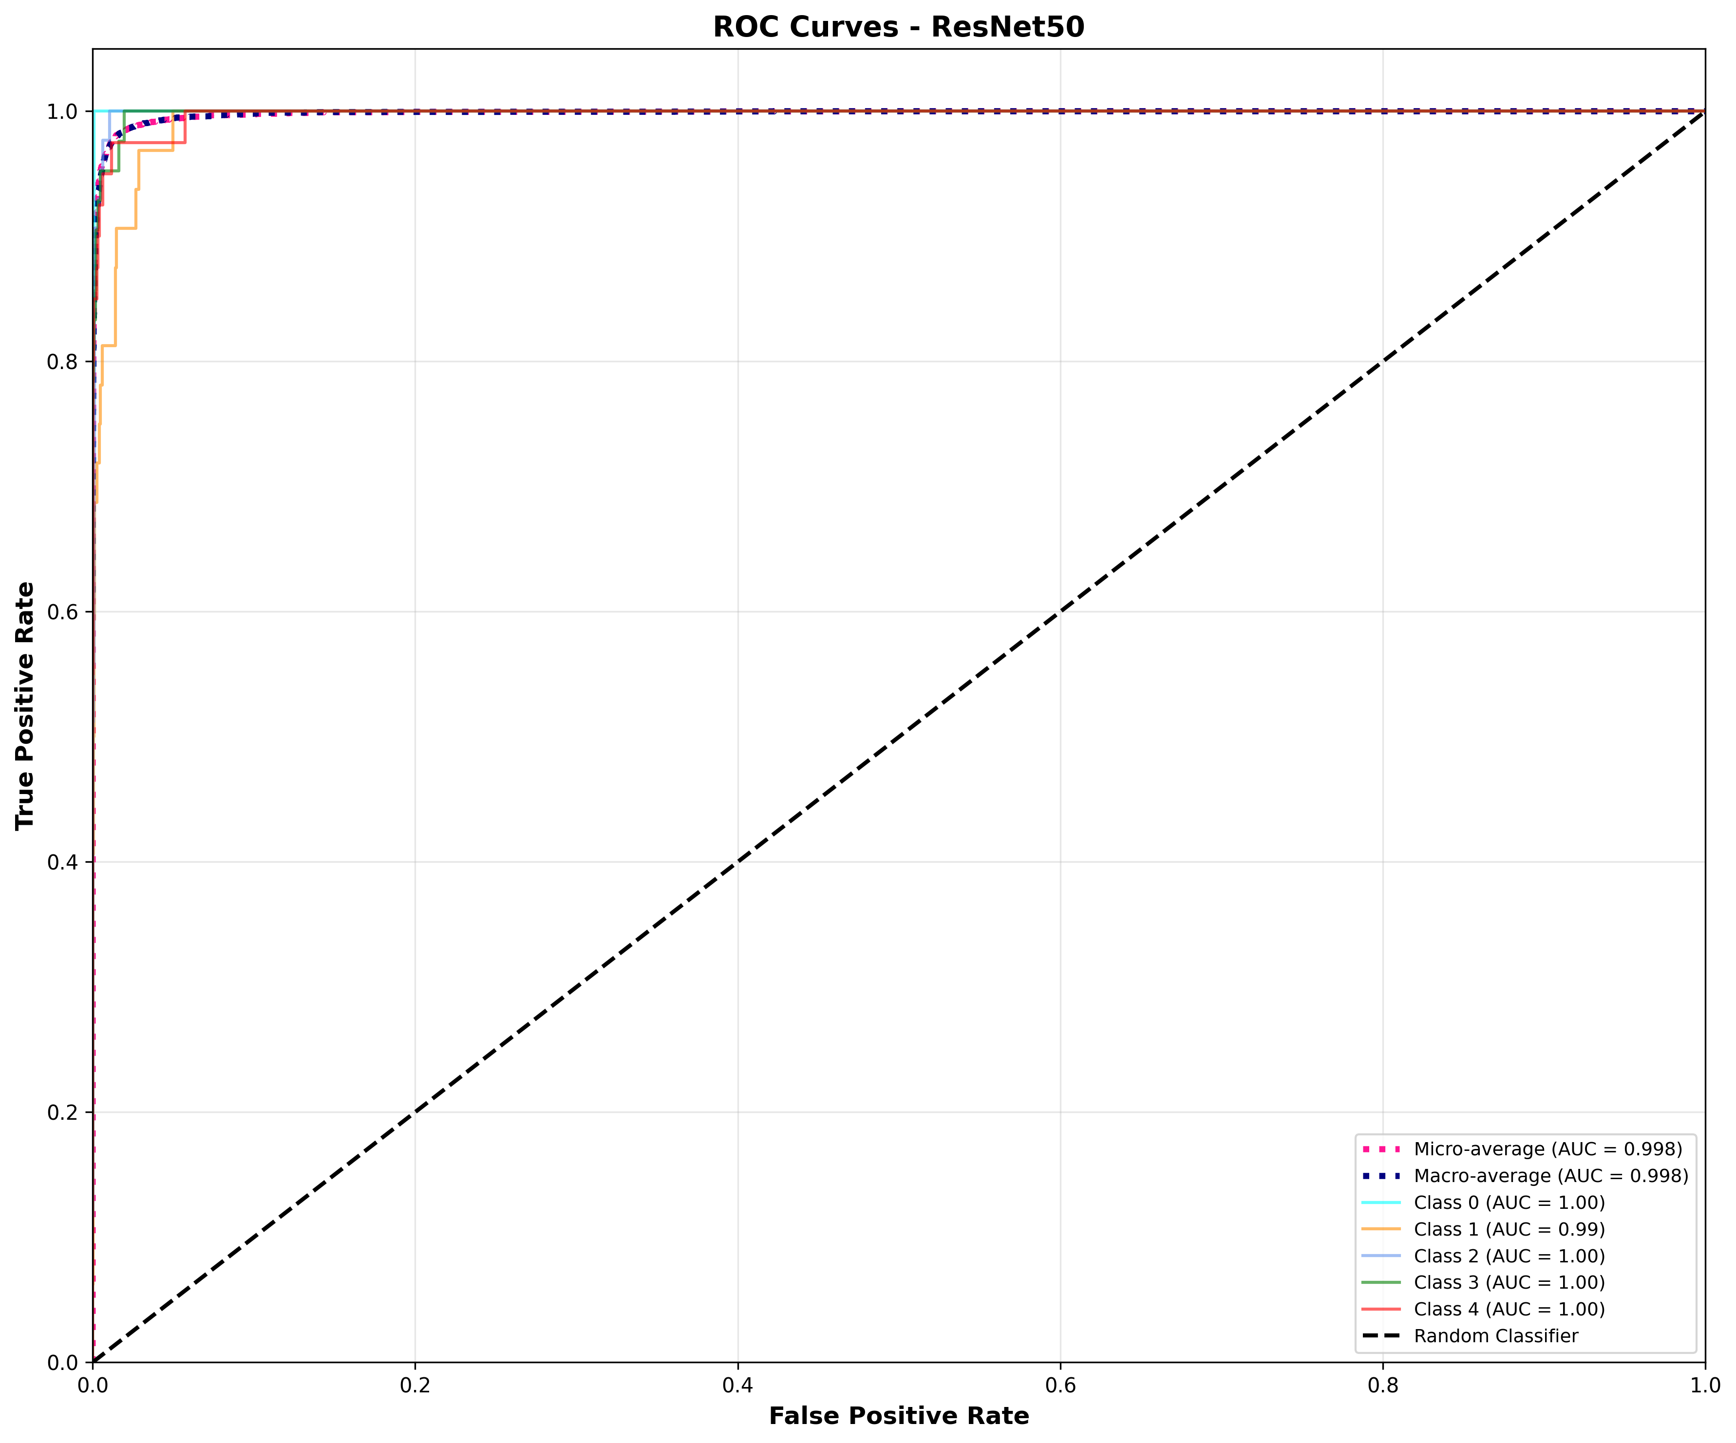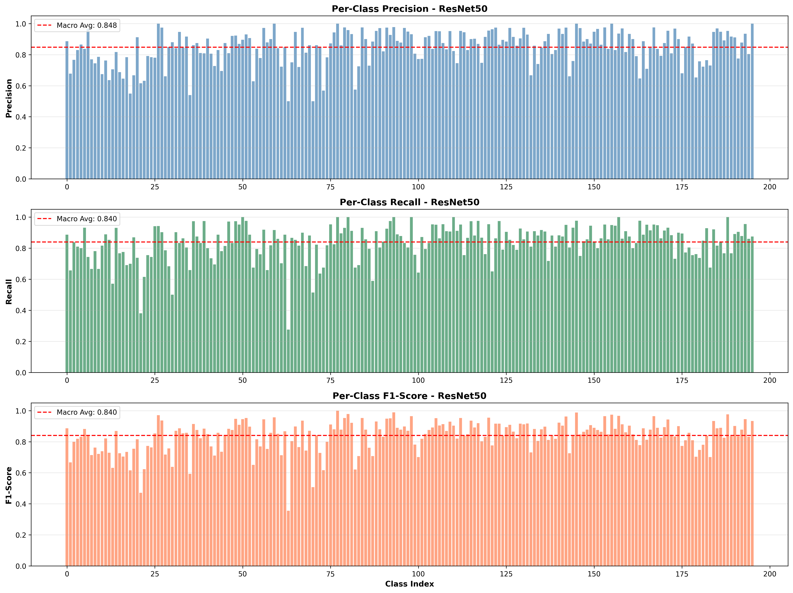

1. **VGG-19**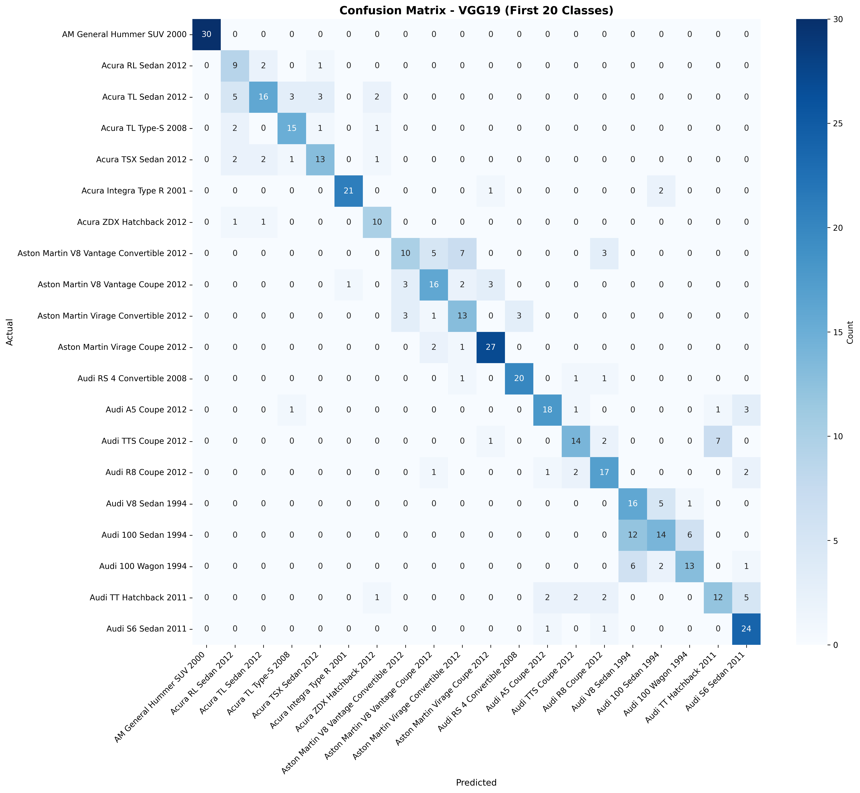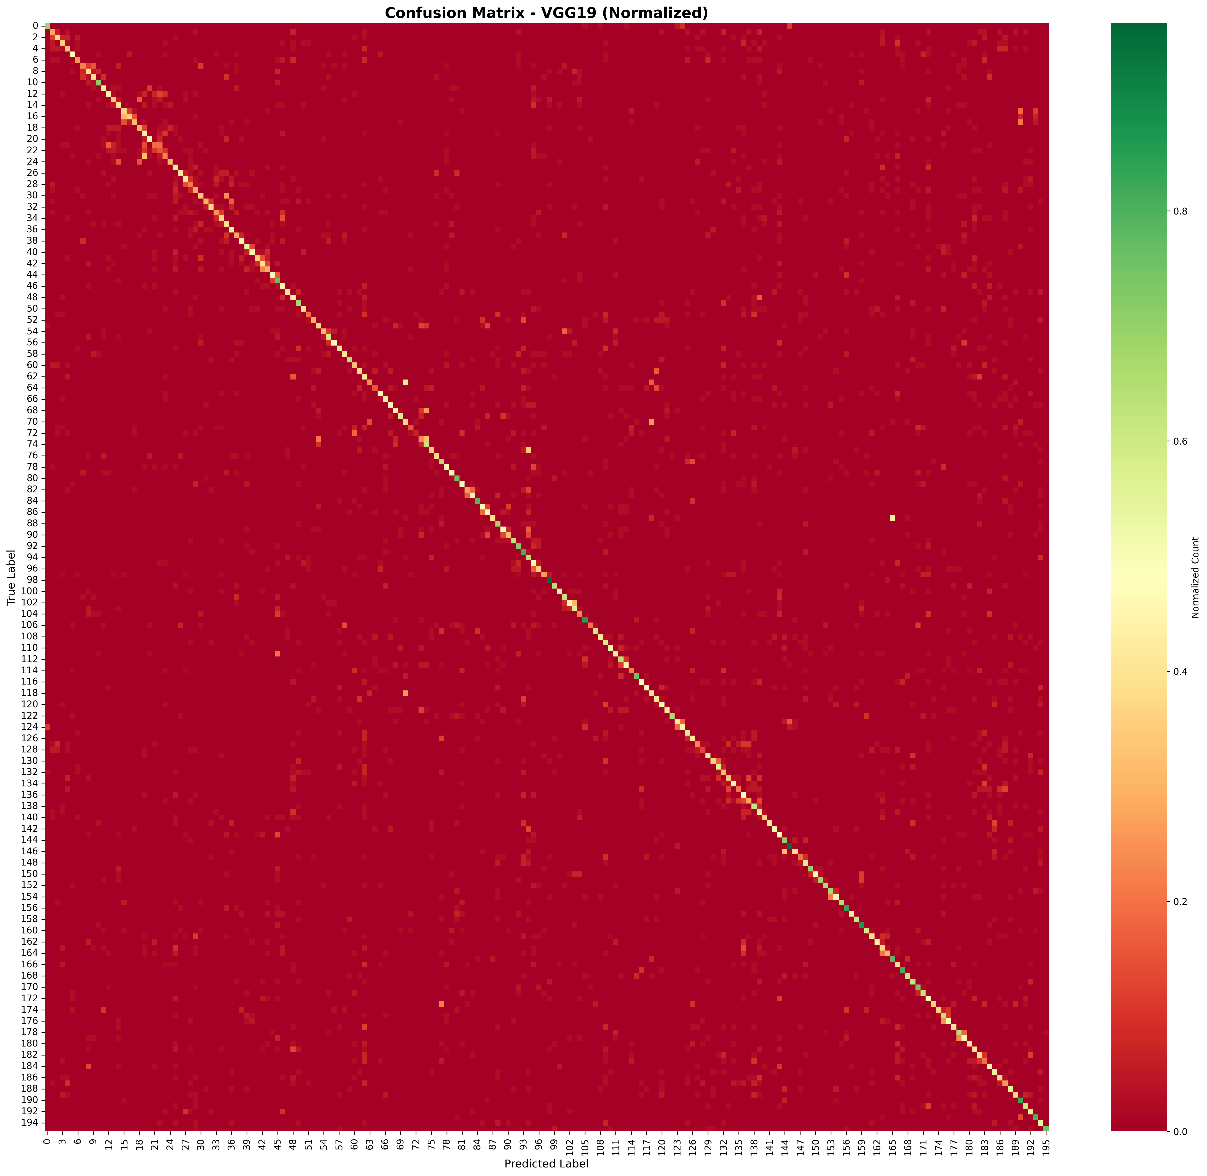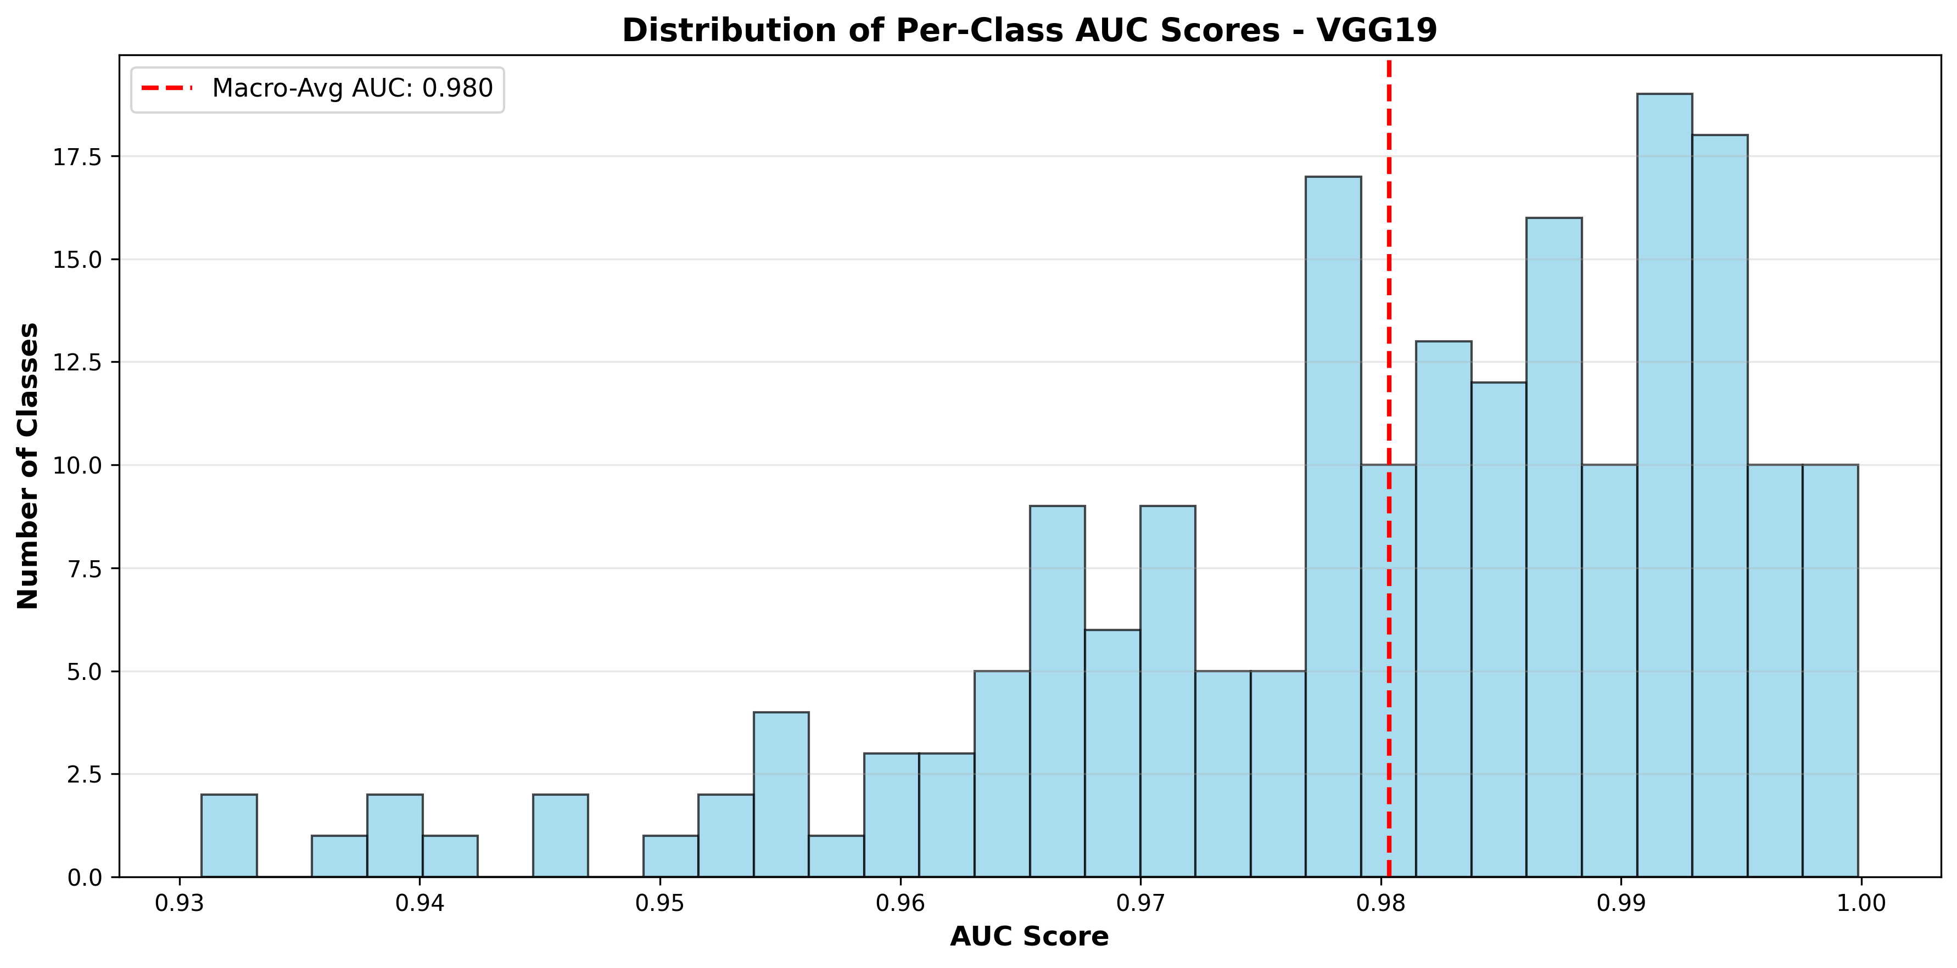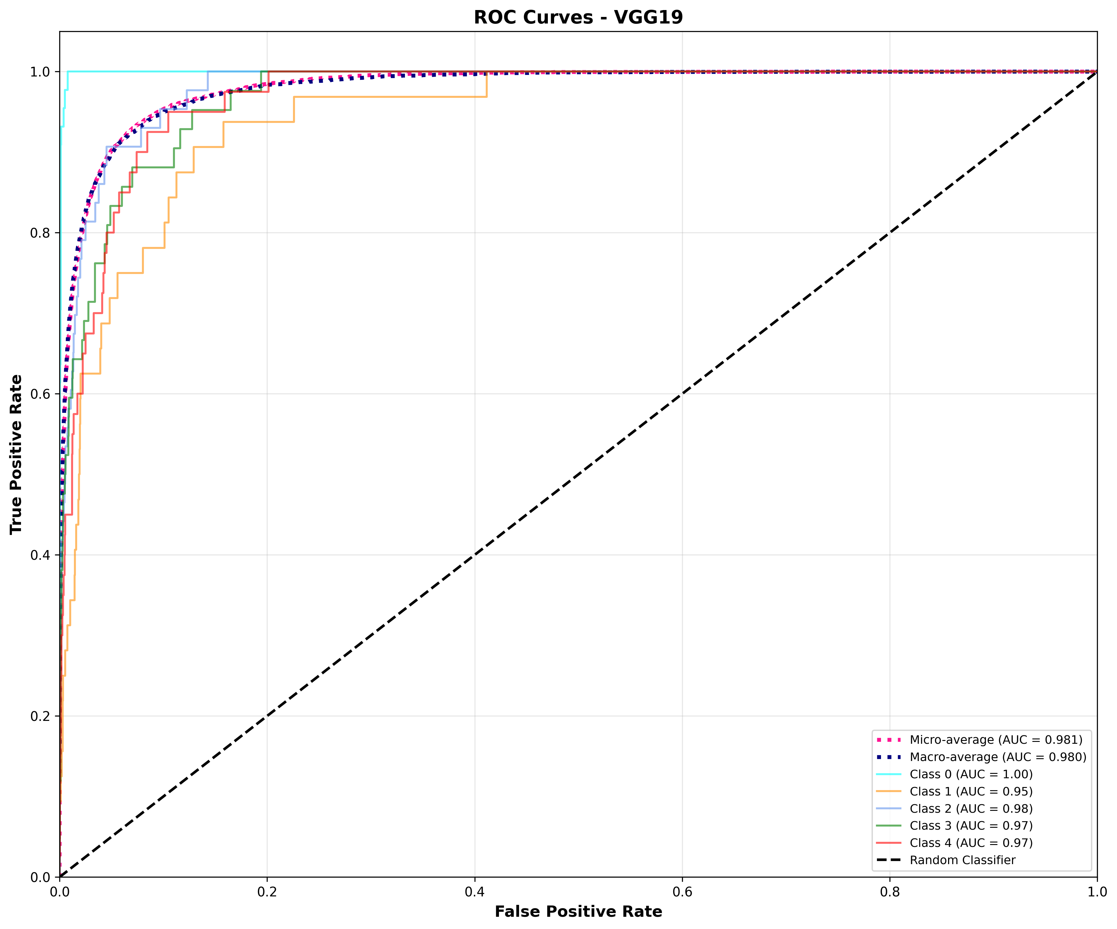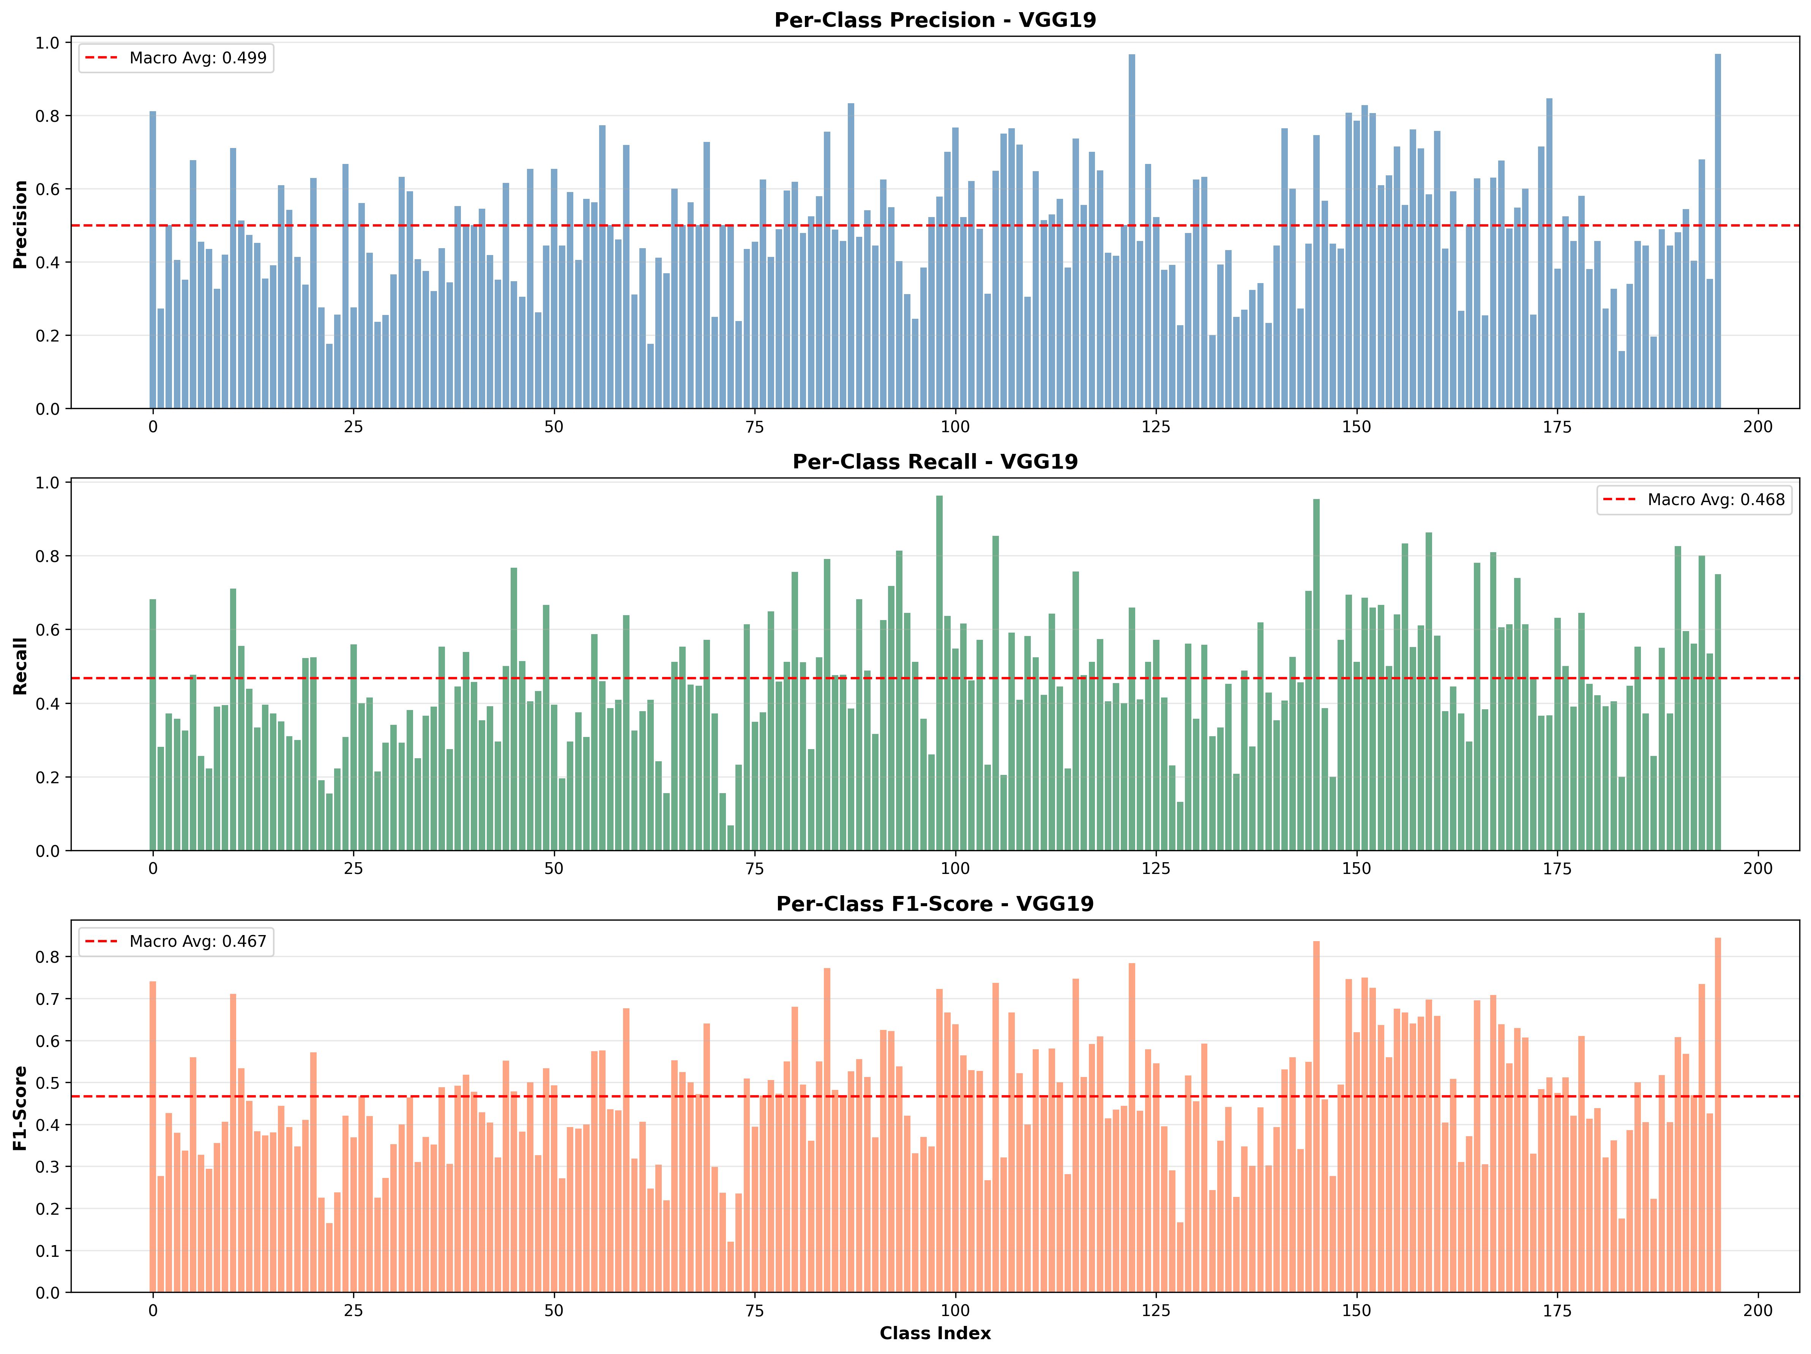
2. **Inception V1**

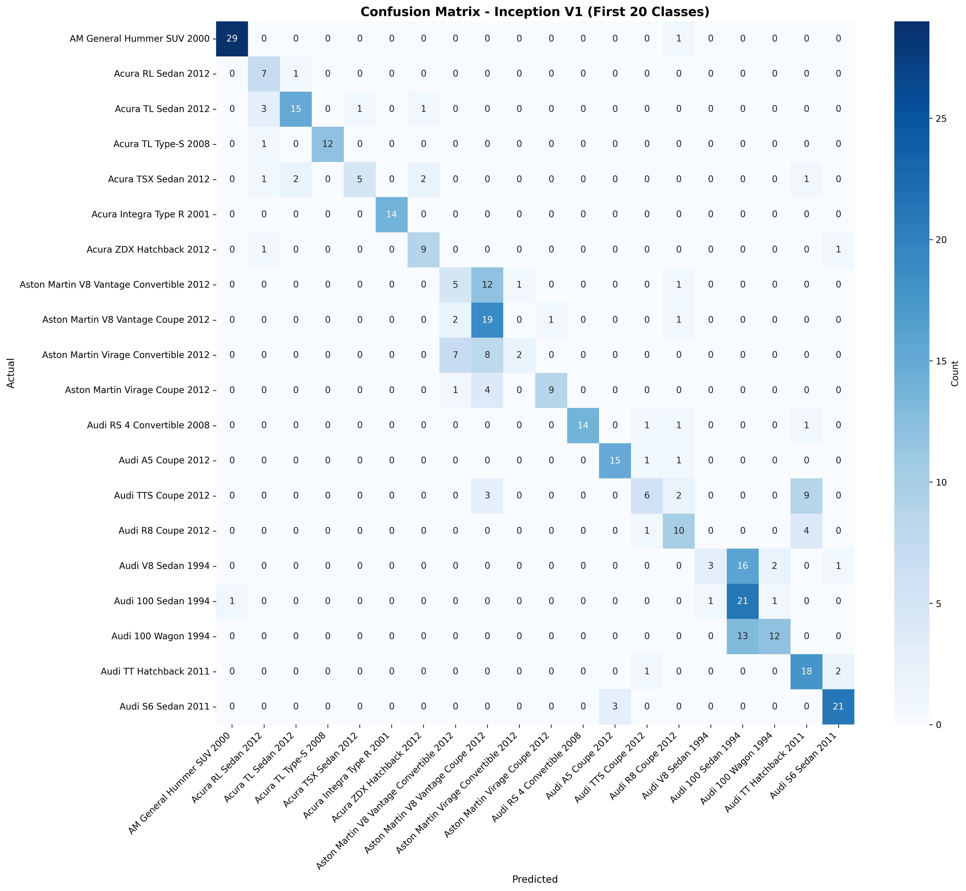

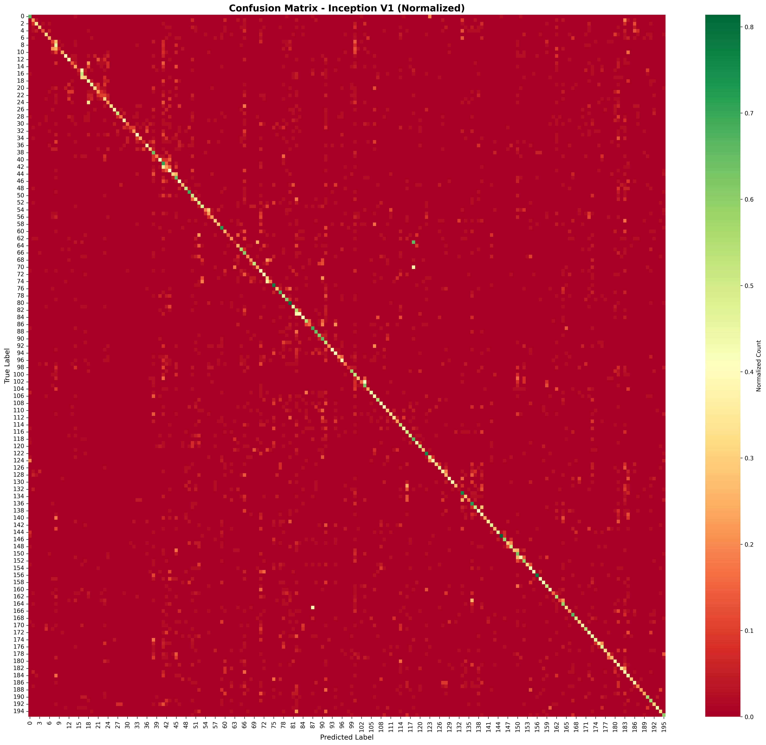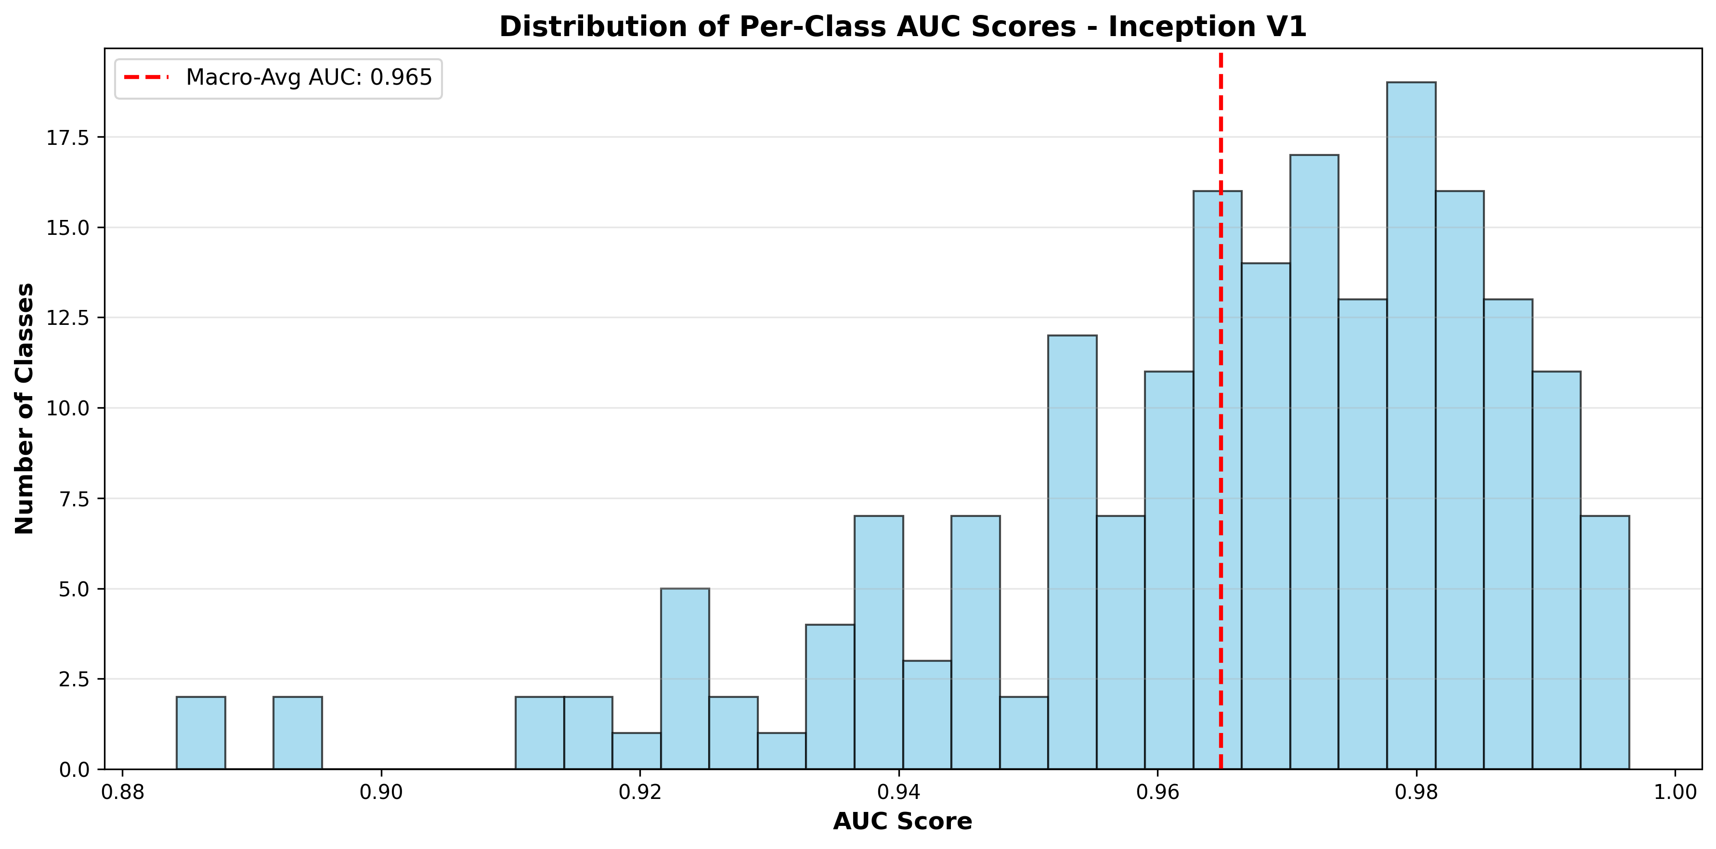

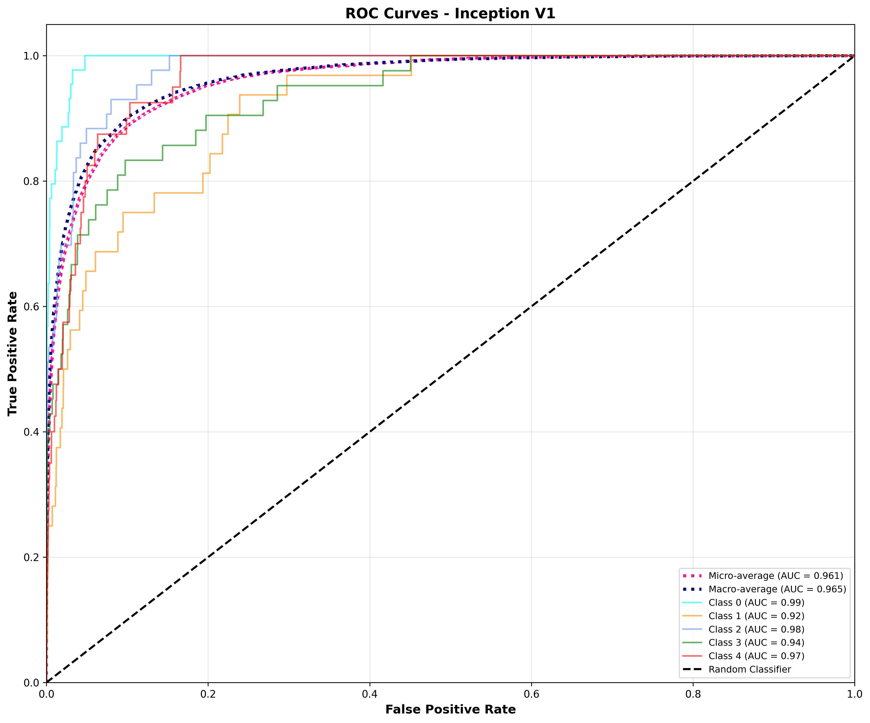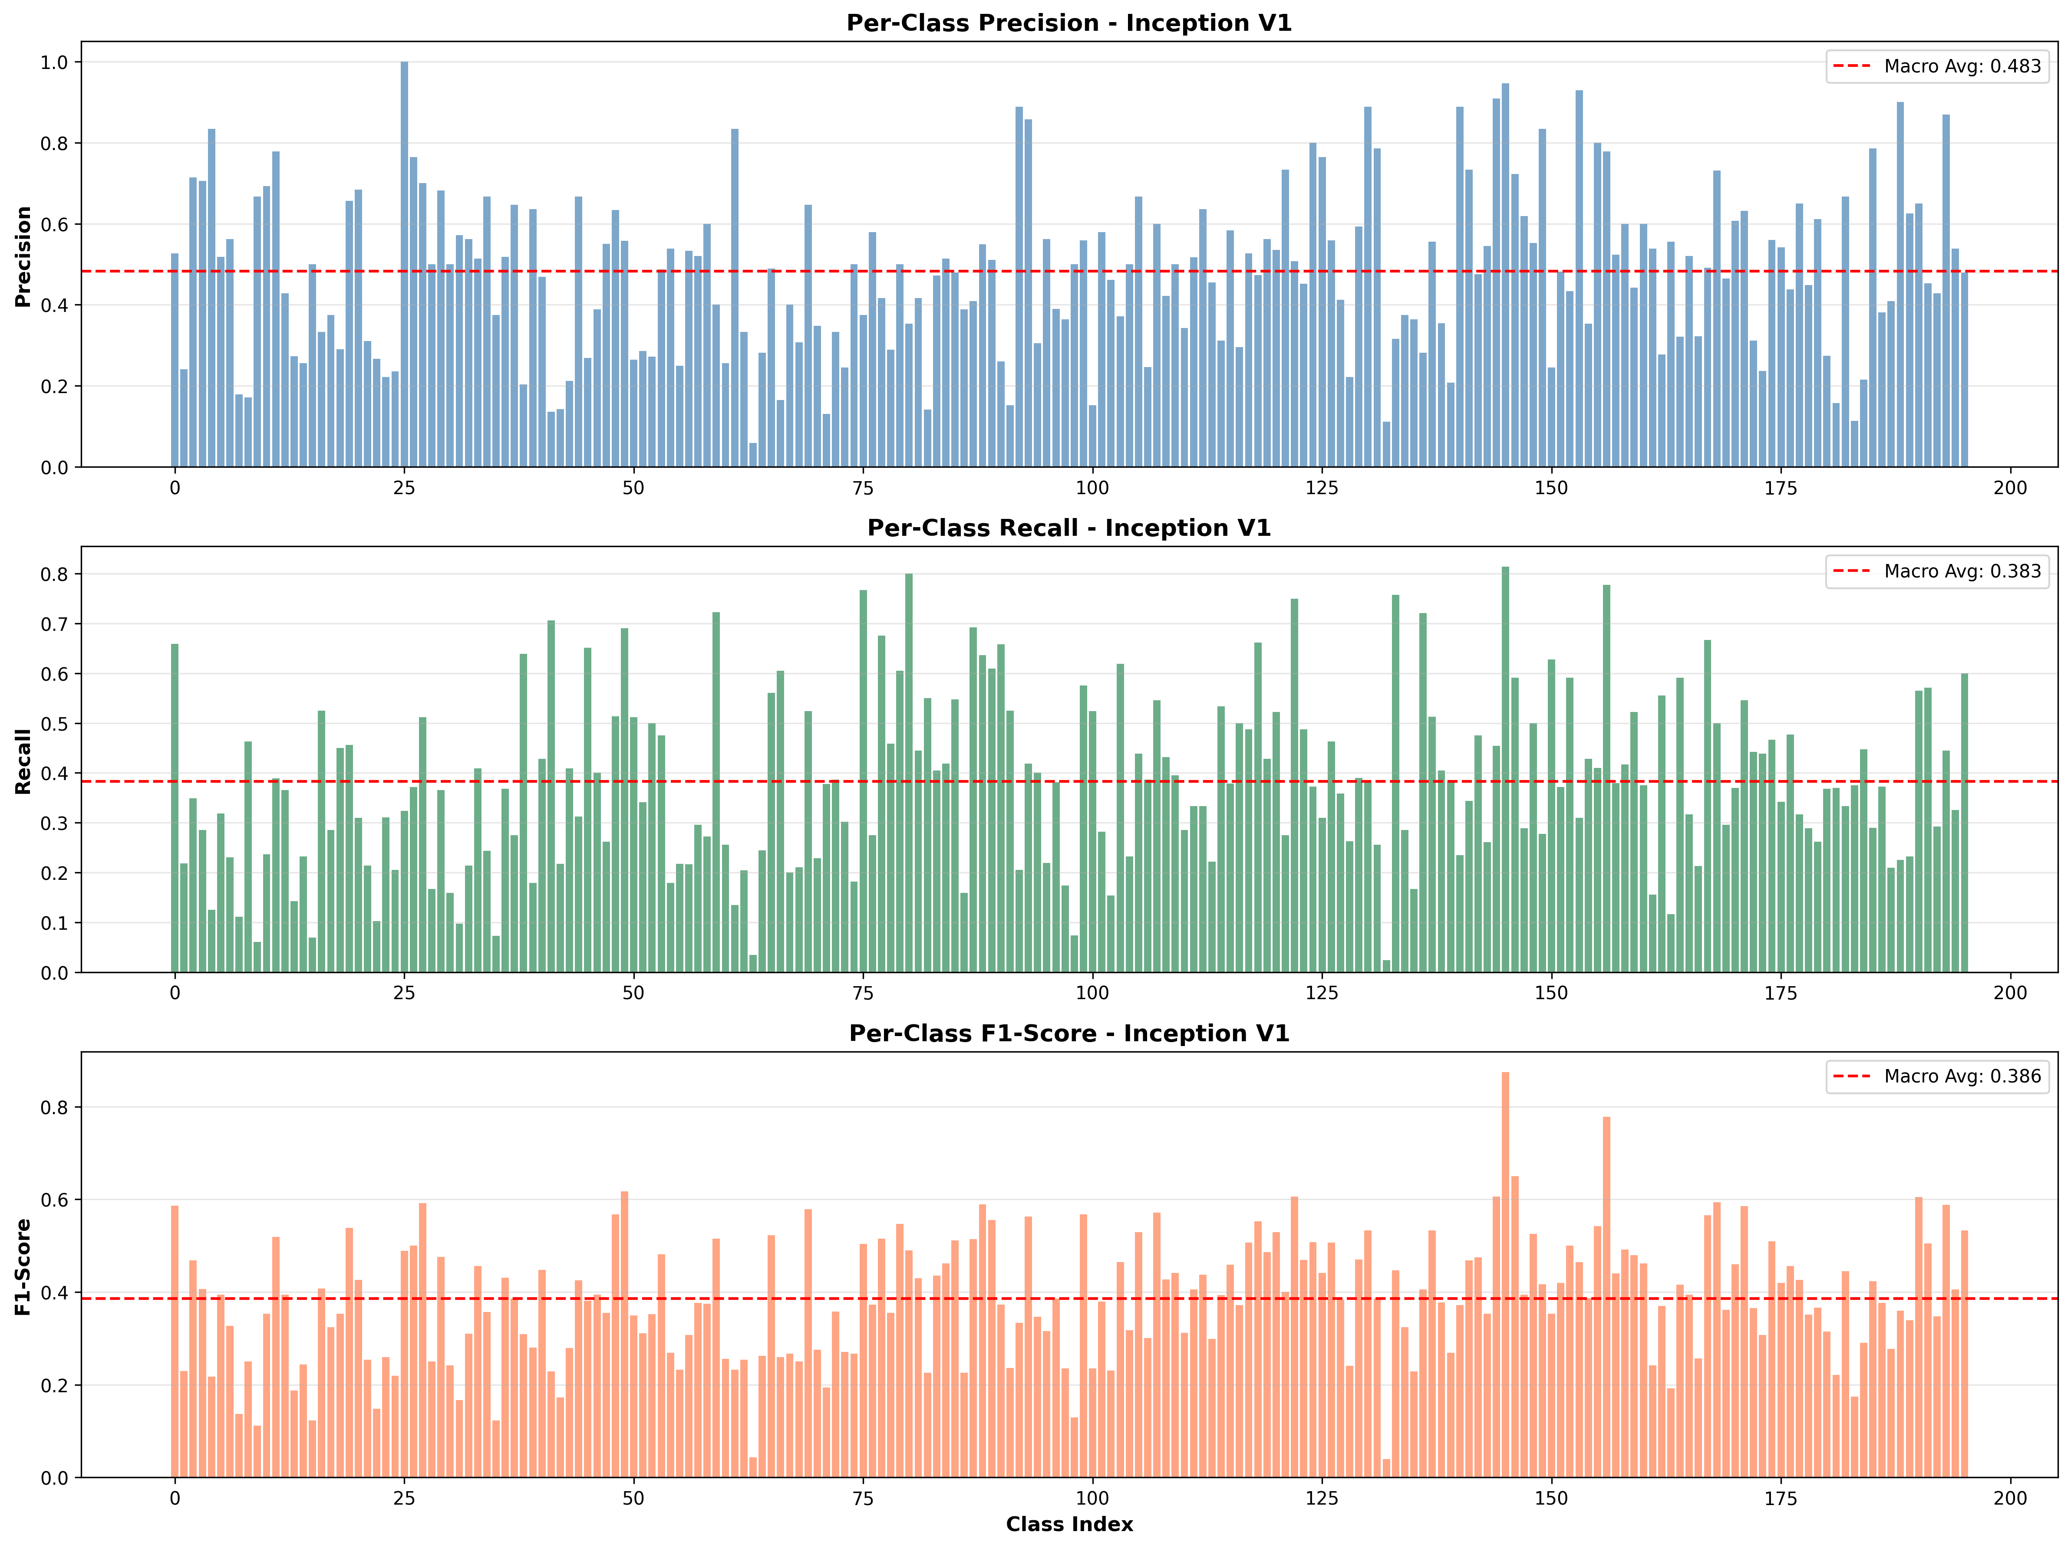

1. **MobileNet V2**

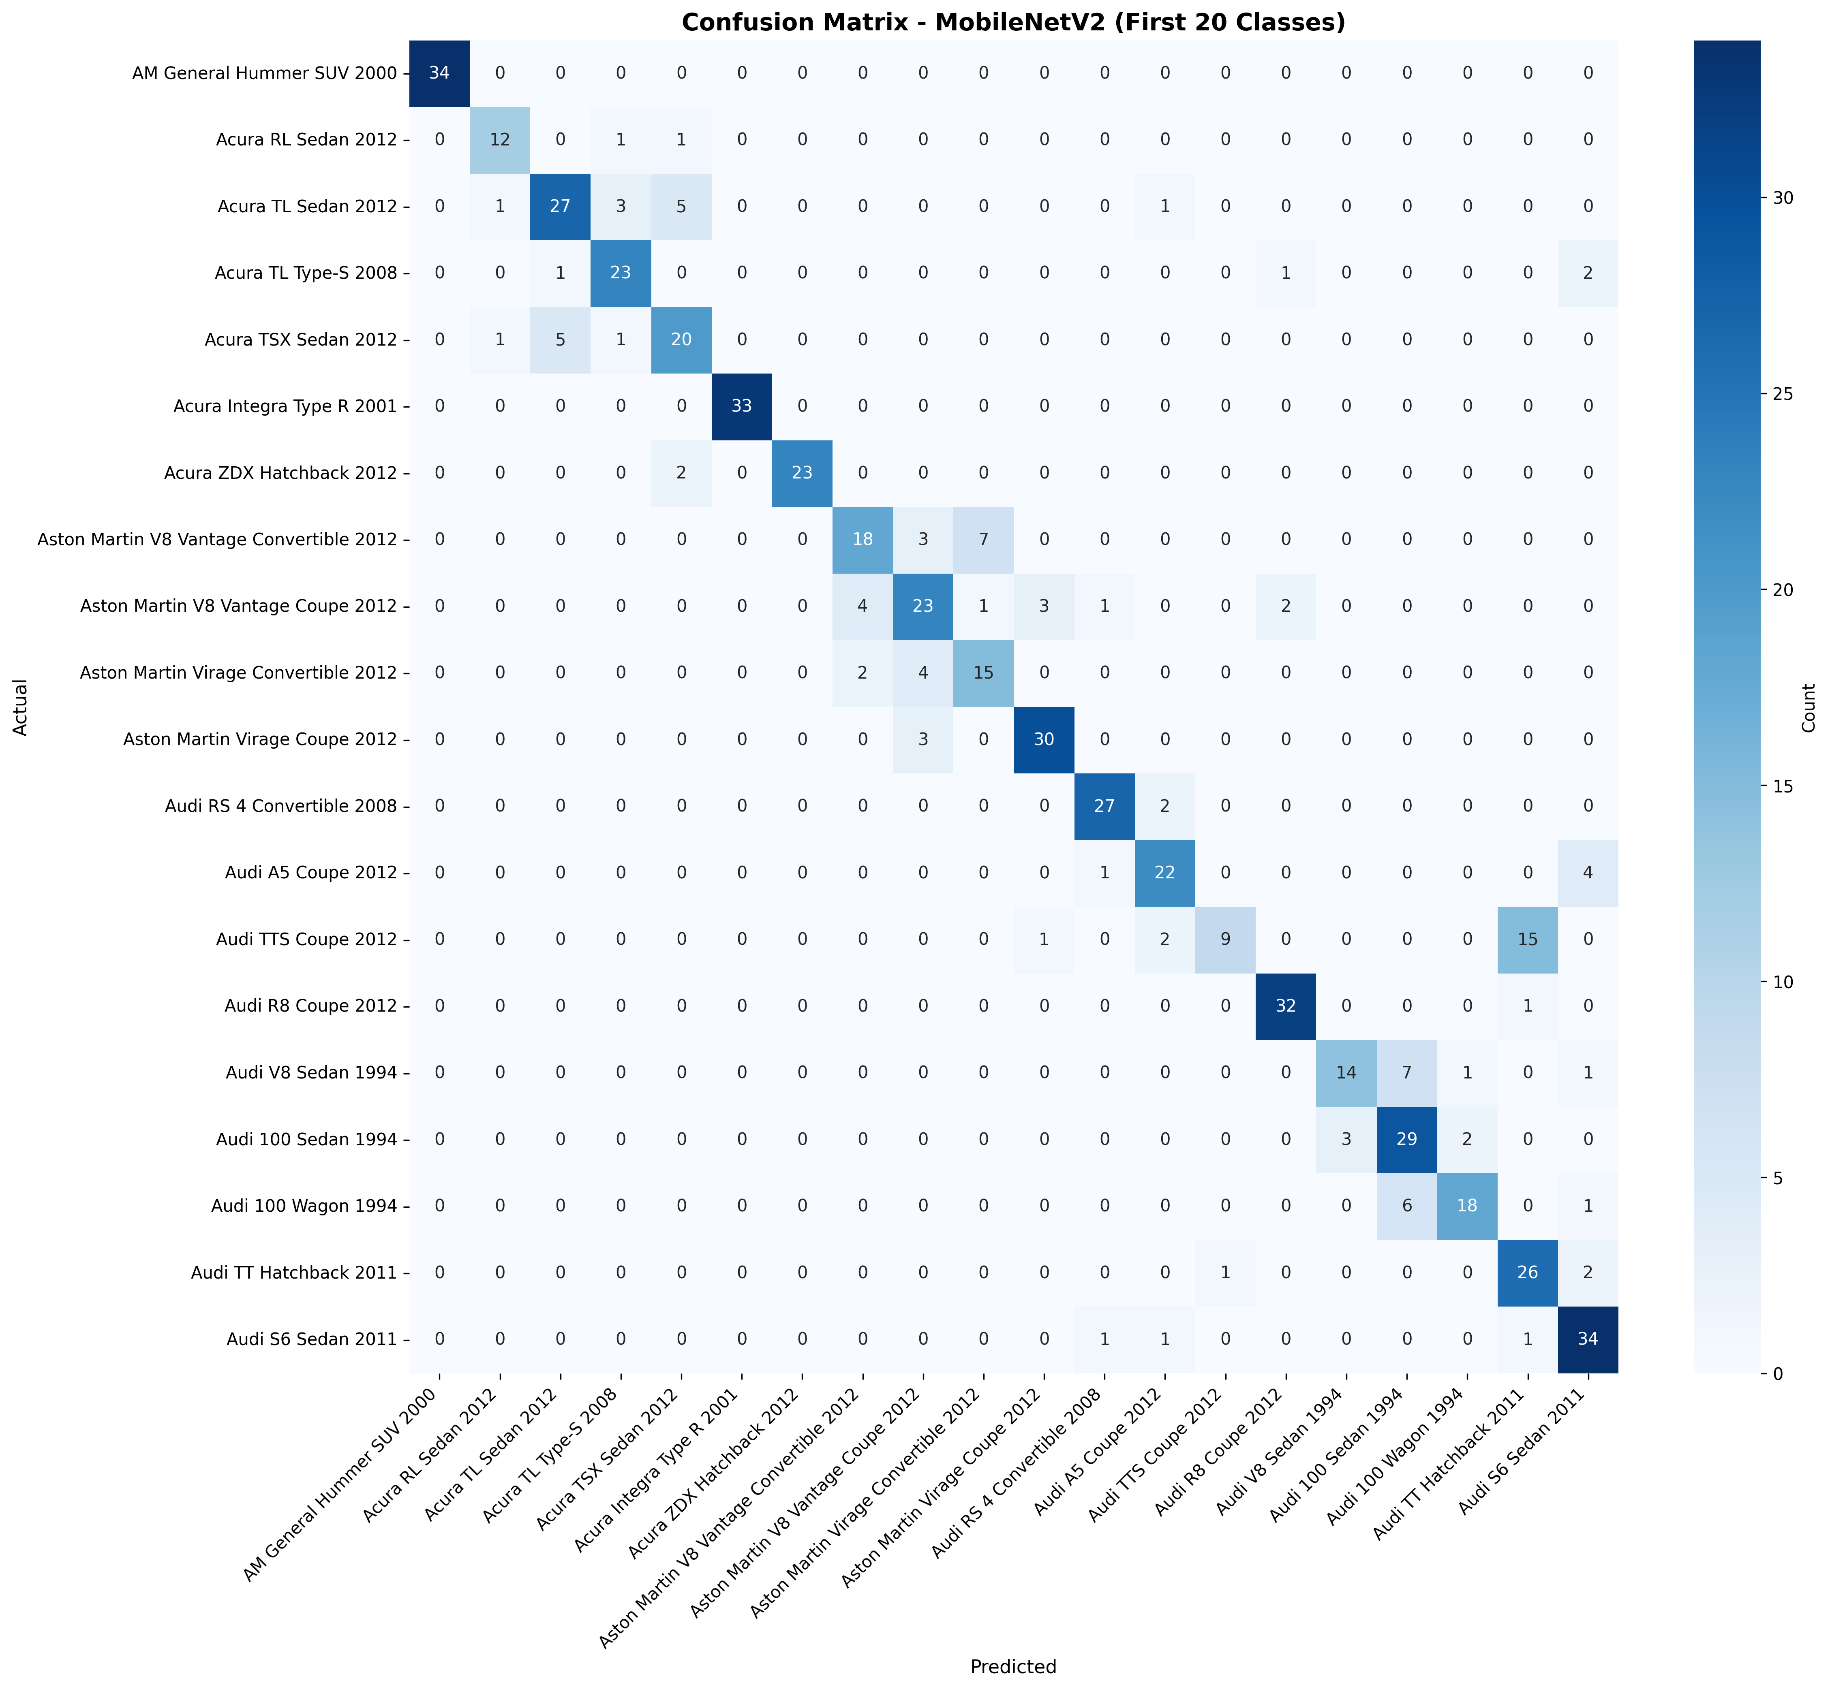

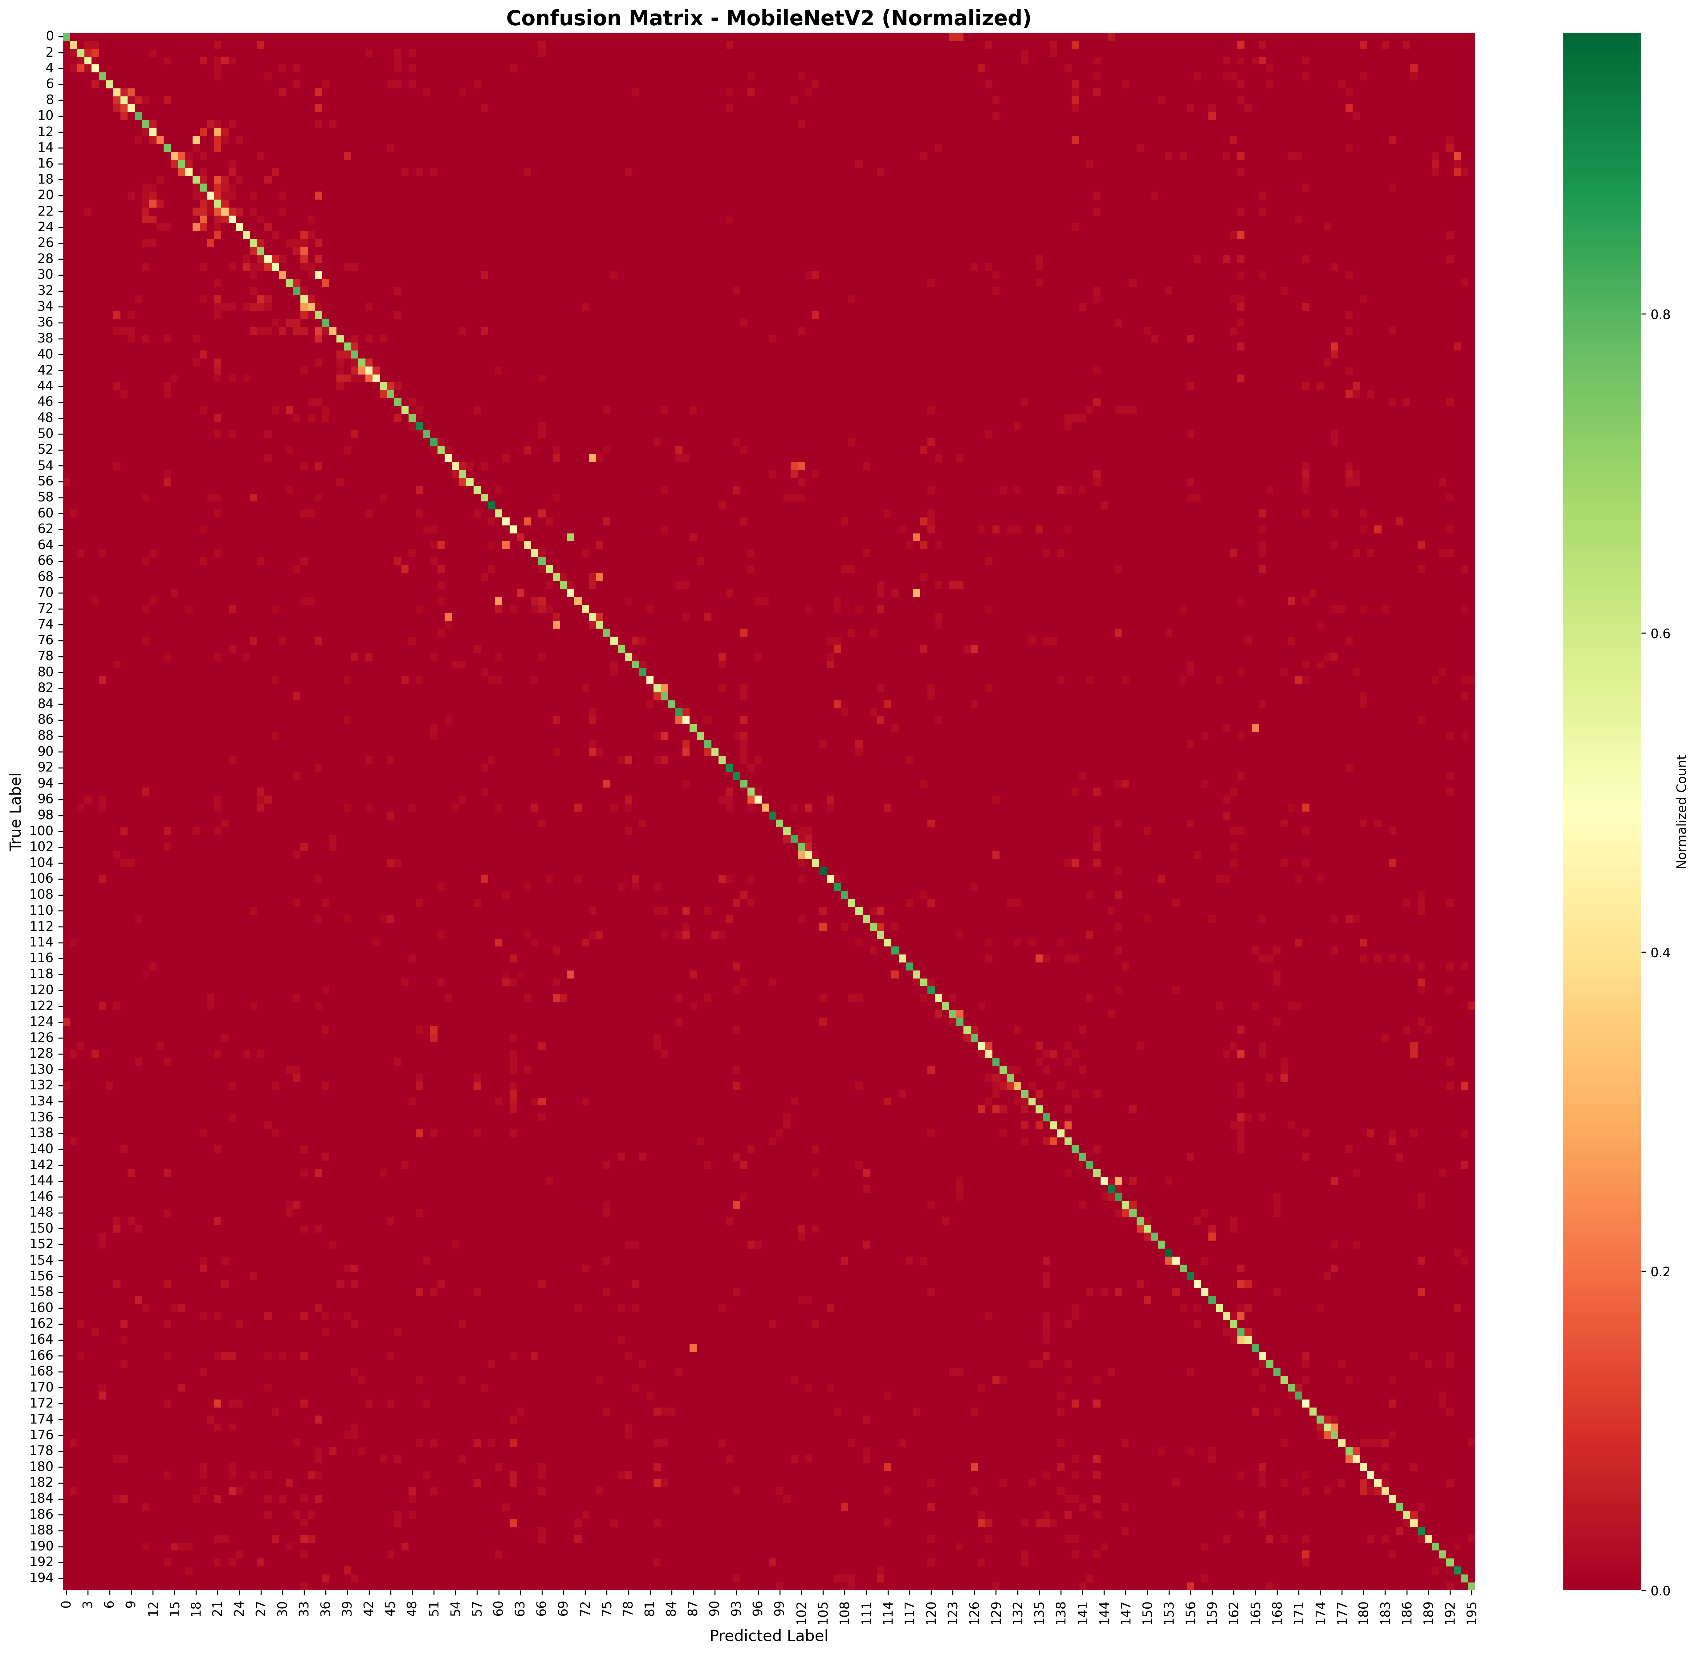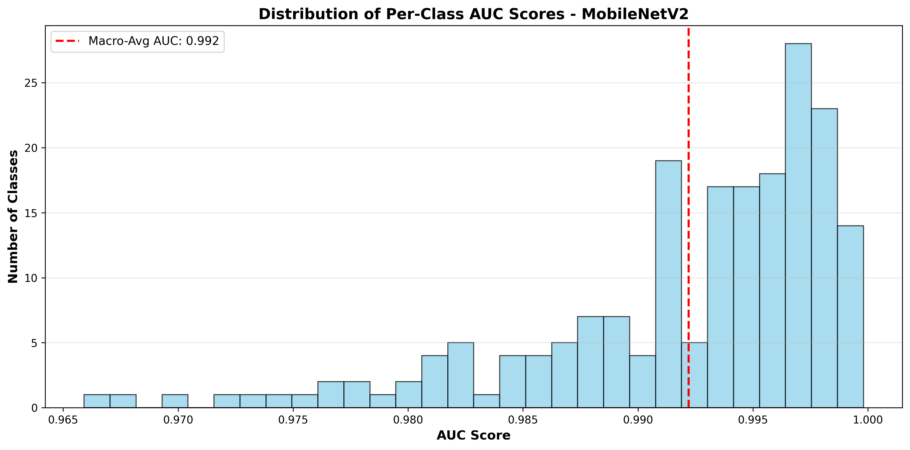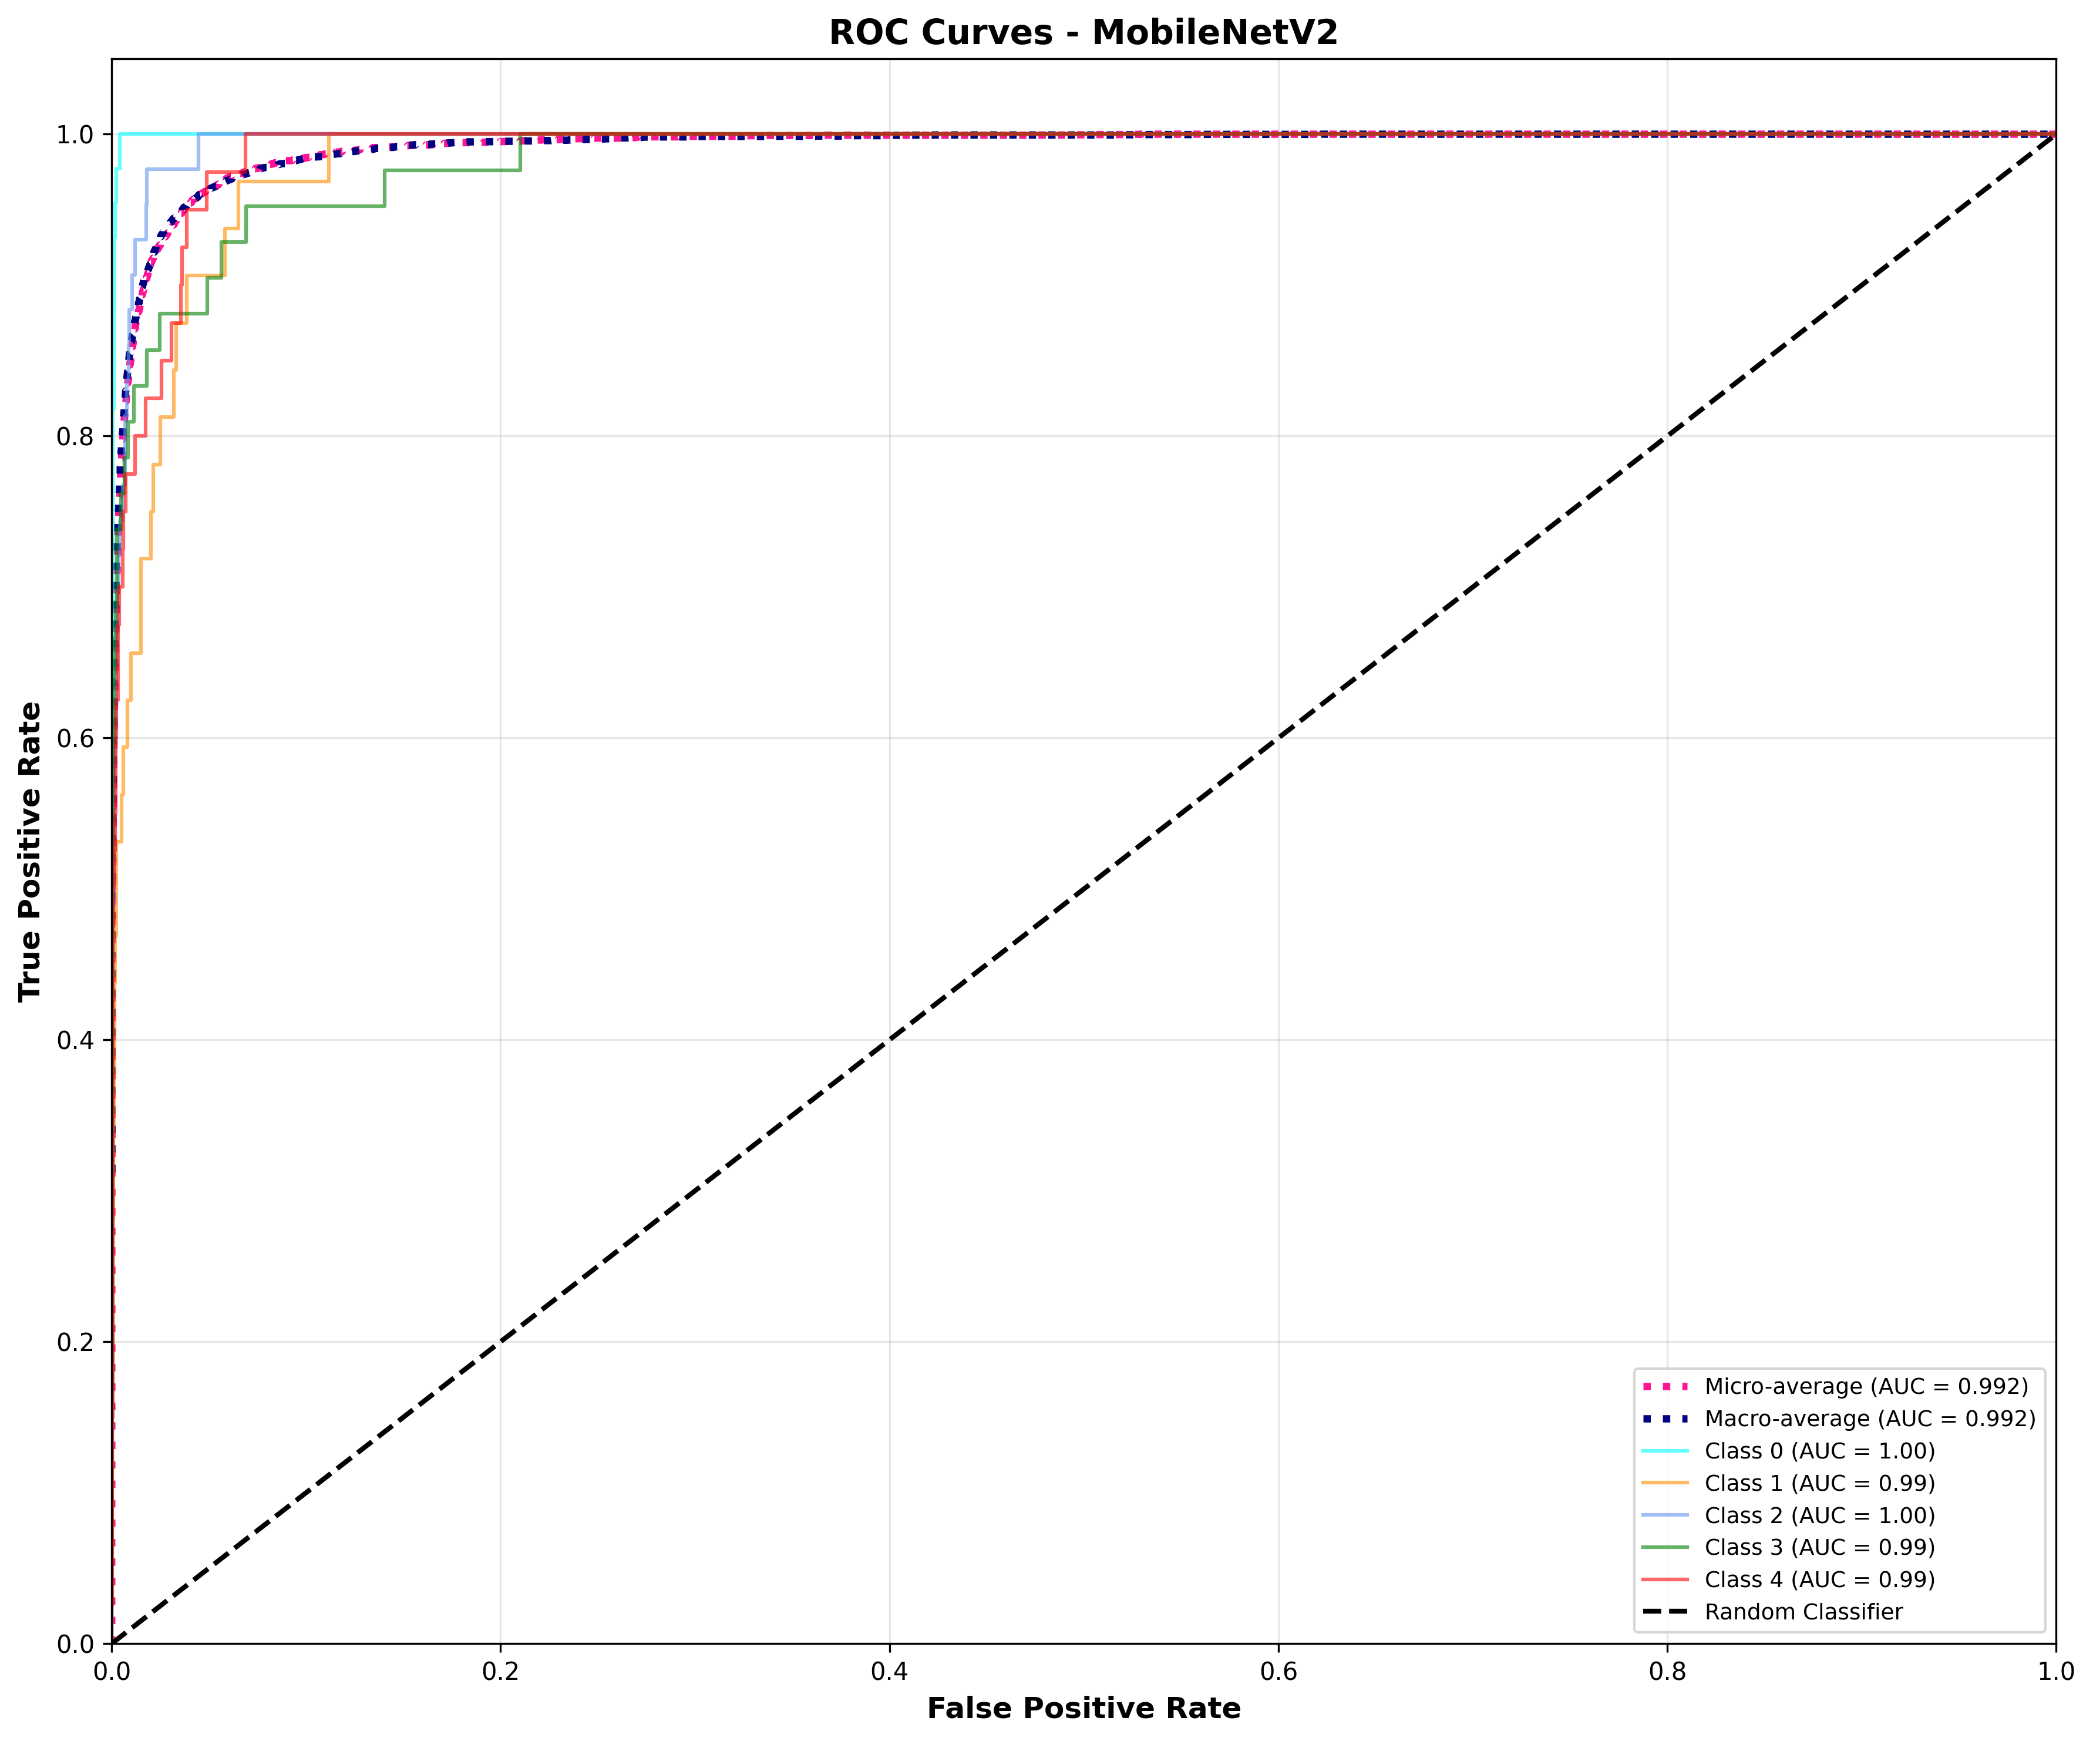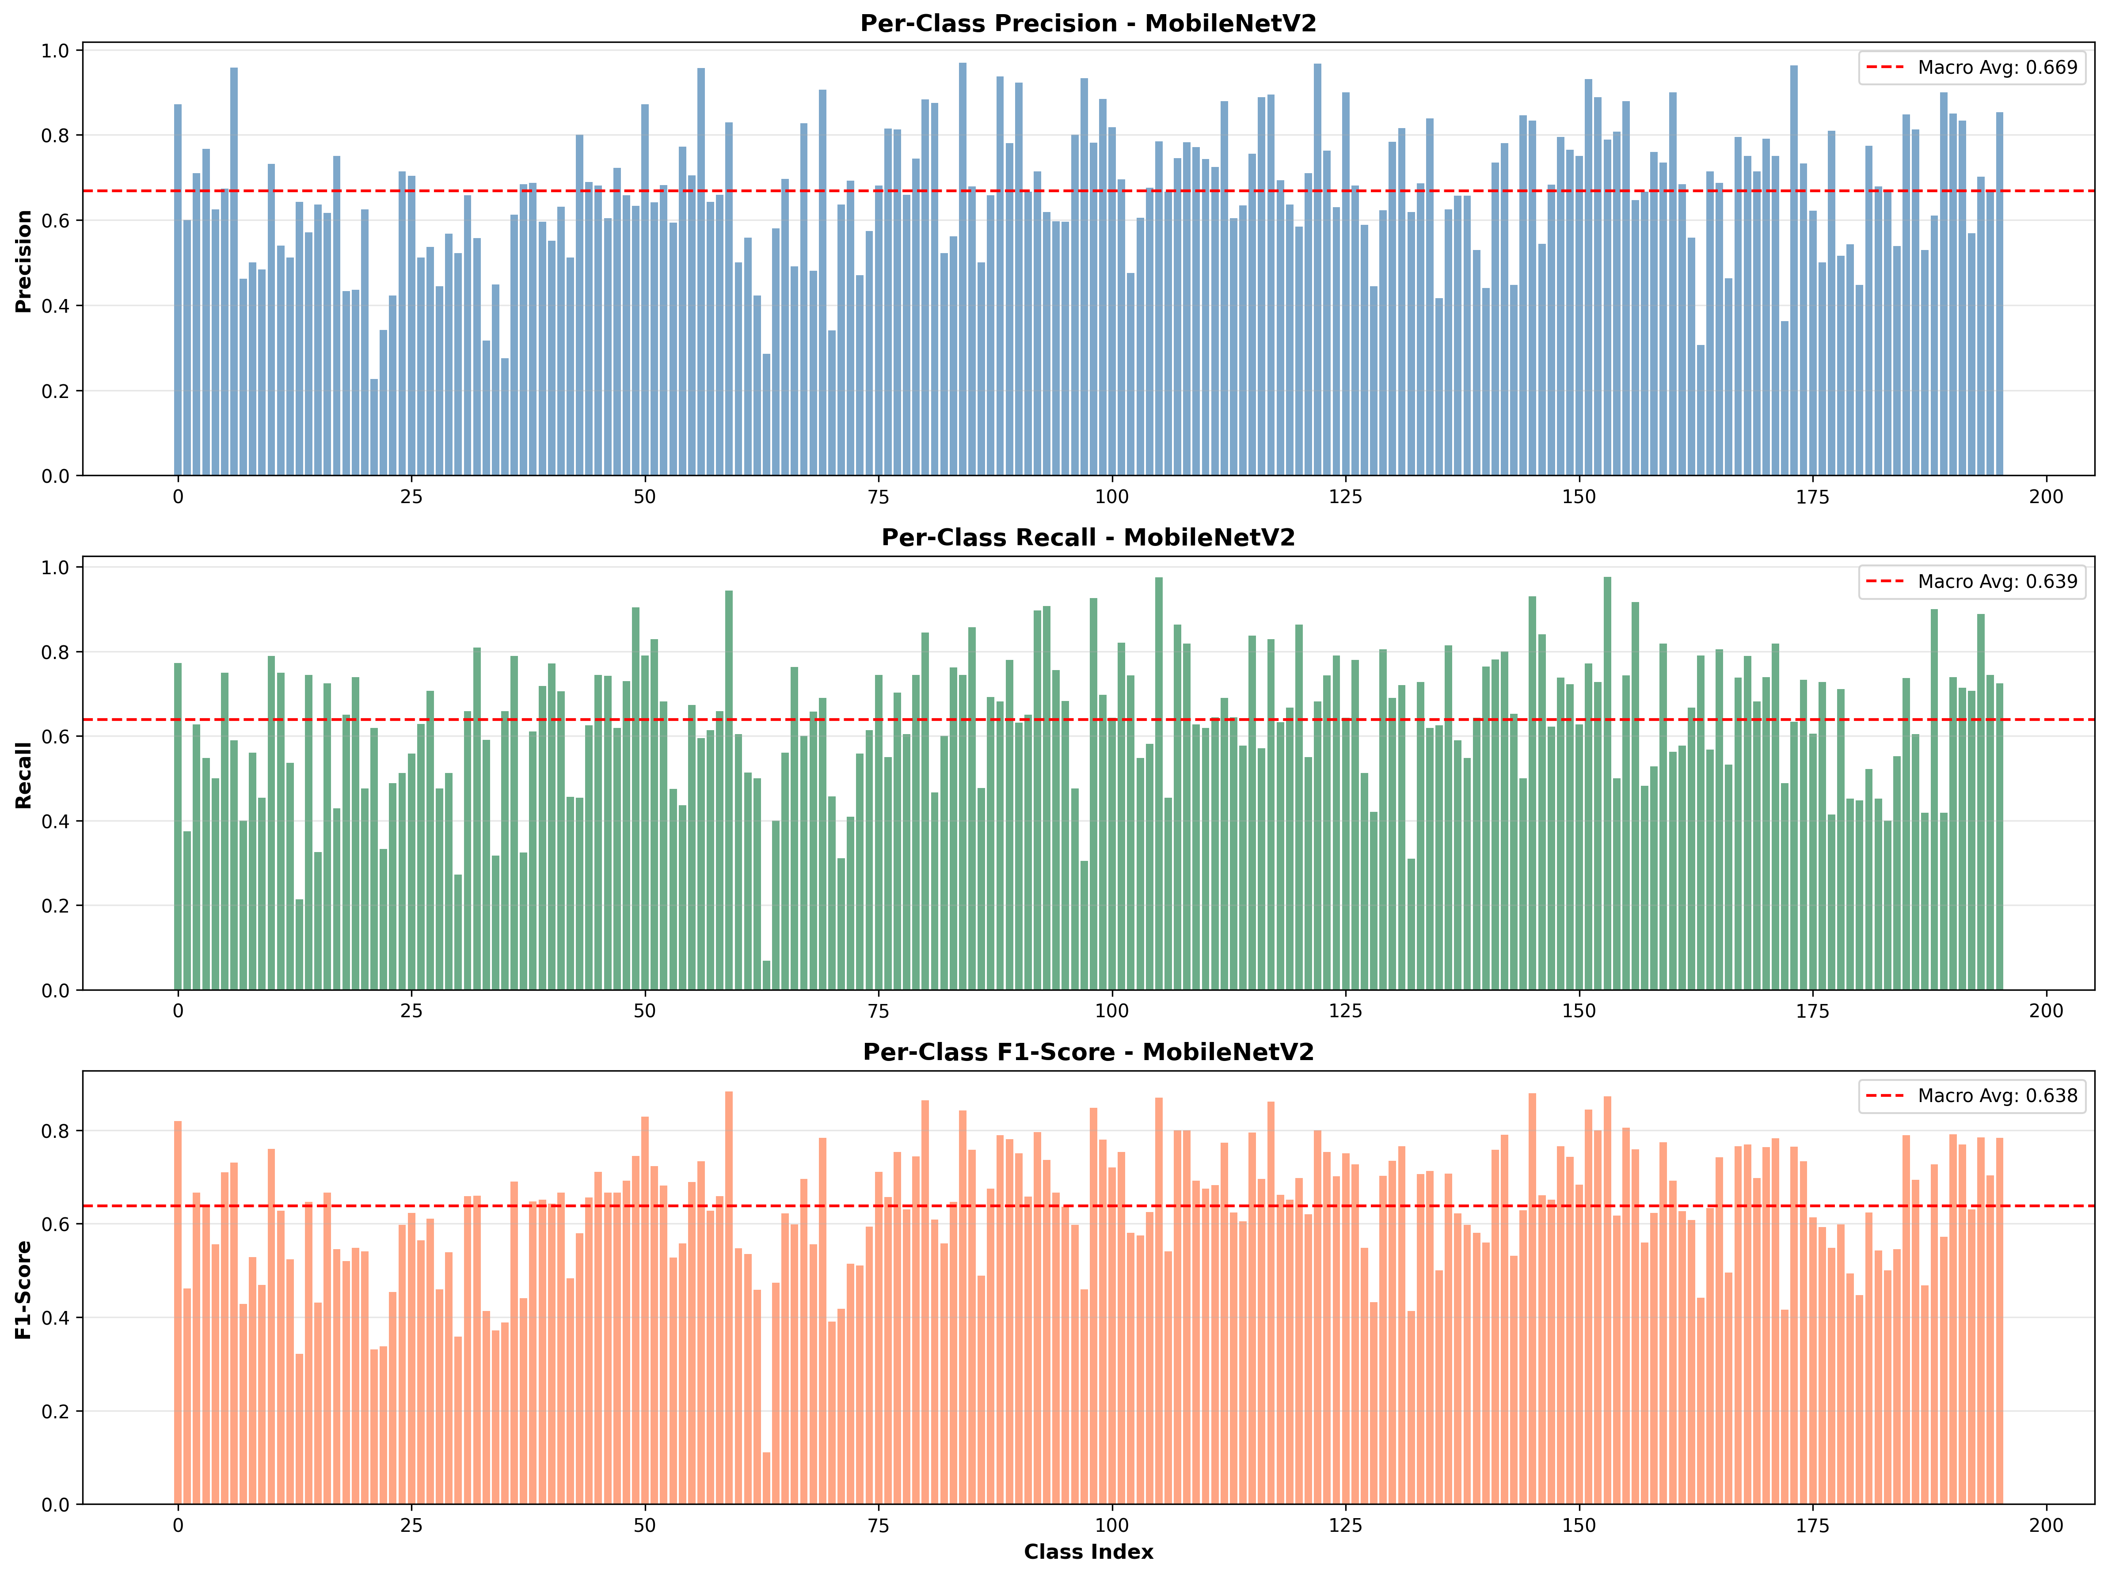

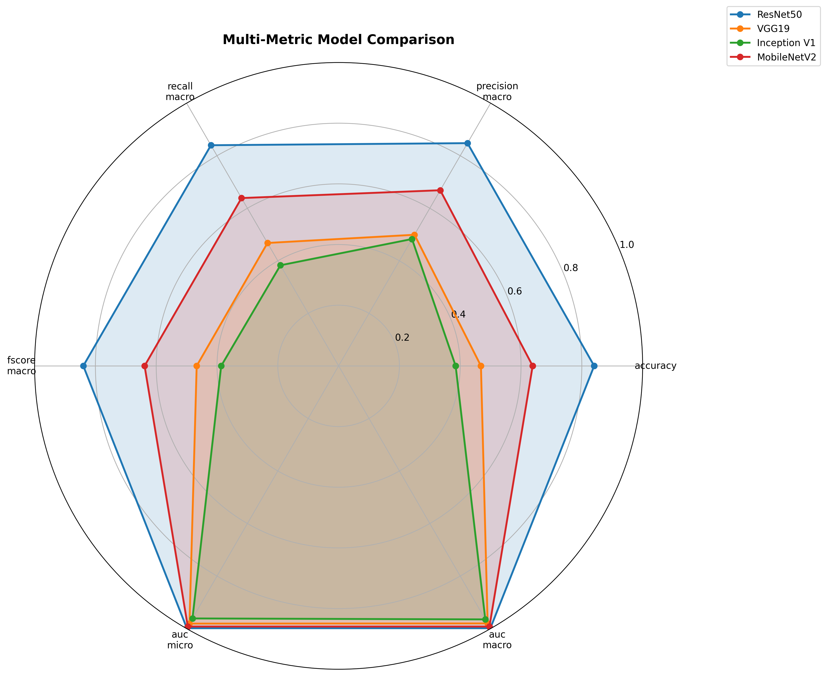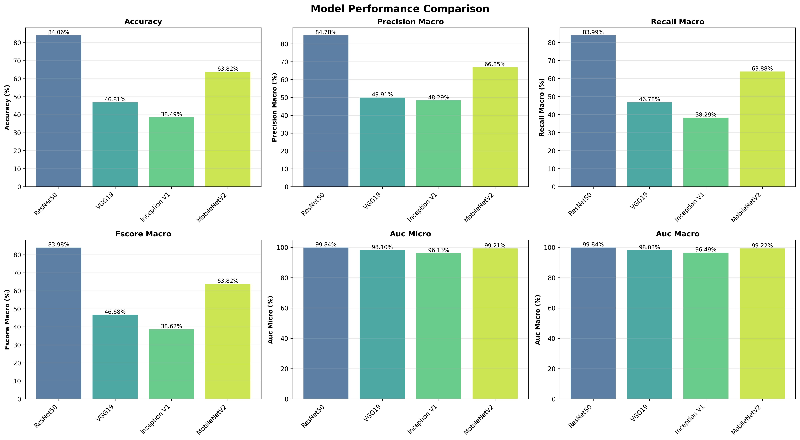  
  
BEST MODEL PER METRIC:

Accuracy: ResNet50 (84.06%)

Precision: ResNet50 (84.78%)

Recall: ResNet50 (83.99%)

Fscore: ResNet50 (83.98%)

AUC Micro: ResNet50 (99.84%)

AUC Macro: ResNet50 (99.84%)

ARCHITECTURE ANALYSIS:  
**ResNet50:**

* Accuracy: 84.06%
* F1-Score (Macro): 83.98%
* AUC (Macro): 99.84%
* **Pros:**
  + Skip connections (H(x) = F(x) + x) enable identity mapping, solving degradation problem
  + Bottleneck design (1×1 → 3×3 → 1×1) reduces parameters while maintaining depth (256 → 64 → 64 → 256)
  + Skip connections create direct paths for gradients, eliminating vanishing gradient problem
* **Cons:**
* Still relatively large for mobile deployment
* Skip connections require storing intermediate activations, increasing memory
* Batch normalization performance degrades with very small batch sizes
* Inference time can be slow on resource-constrained devices

**VGG19:**

* Accuracy: 46.81%
* F1-Score (Macro): 46.68%
* AUC (Macro): 98.03%
* Pros:
* Uses only 3×3 convolutions with stride 1, padding 1, and 2×2 max pooling with stride 2 throughout
* 19 layers (16 conv + 3 FC) create rich hierarchical representations
* Performs well on image classification tasks and generalizes effectively to transfer learning
* Simple sequential structure makes backpropagation straightforward
* **Cons:**
  + Extremely large number of parameters making it memory-intensive and prone to overfitting
  + Slow to train and requires significant computational resources
  + Deep sequential architecture without skip connections leads to vanishing gradients

**Inception V1:**

* Accuracy: 38.49%
* F1-Score (Macro): 38.62%
* AUC (Macro): 96.49%
* **Pros:**
  + Parallel 1×1, 3×3, 5×5 convs and 3×3 pooling capture features at different scales simultaneously
  + 1×1 convolutions before expensive operations reduce computational cost dramatically
  + Two auxiliary outputs at intermediate layers combat vanishing gradients
* **Cons:**
* 9 inception modules with different configurations make implementation error-prone
* Multiple parallel branches with different kernel sizes complicate optimization and hardware utilization
* Requires careful weighting of auxiliary losses against main loss
* Inception modules can be computationally expensive despite parameter efficiency
* Has been largely superseded by later versions (V2, V3, V4) and other architectures

**MobileNetV2:**

* Accuracy: 63.82%
* F1-Score (Macro): 63.82%
* AUC (Macro): 99.22%
* **Pros:**
* Splits standard conv into depthwise (3×3 per channel) + pointwise (1×1) making computation more efficient
* Inverted residuals which expands channels (thin → wide → thin) is better for low-dimensional images
* Removes ReLU from final layer in linear bottlenecks to preserve information in low-dimensional space
* 6x expansion in inverted residuals using ReLU6 provides sufficient representational capacity
* **Cons:**
  + Thin architecture limits ability to learn complex features
  + Less feature richness for transfer learning to demanding tasks
  + Depthwise convolutions can be harder to optimize on certain hardware